**SAP Style Guide**

**SAP R/3 and Webdynpro ABAP Developments**

**(UI Guidelines Additions)**

**Created By:**

**Shruti Pardakhe**

**Shivam Dubey**

**Nandita Pathania**

**Document History:**

|  |  |  |  |
| --- | --- | --- | --- |
| **Revision** | **Date** | **Author** | **Comments** |
| 1.0 | 03-Jul-2013 | Shruti Pardakhe,  Shivam Dubey, Nandita Pathania | Initial Version |

**For Report Program- Selection Screen:**

* On selection screen, no abbreviations allowed.
* Screen field labels must be title case i.e. first letter of every word capital except for connecting words as for, by, the, from. (e.g. Port of Dispatch) But if the same words are first or last word of label then title case must be followed for it. (e.g. Created By)
* At least one mandatory field should be there on selection screen and field level validation for the same is mandate.
* Back, Exit and Cancel buttons functionality must be as below.
* Back - Previous Screen
* Exit - SAP Main Menu
* Cancel - First screen of Program
* Output variant to save layout is mandatory on selection screen with frame title as Layout Selection and field label as Output Variant.

**For Report Program – Output:**

* For output, please refer to standard toolbar of ALV shown below**.**

ALV toolbar for report output should have following buttons given in screenshot below as a mandate.

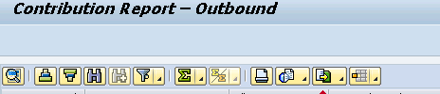

If any other buttons are required as per functional requirement, the same can be given after these buttons.

* All the icons used for buttons should be cross verified with follow UI guidelines document.
* Amount and Quantity fields should always be displayed right justified while all other fields should be left justified.
* Please provide Unit of Measure for quantity and Currency for Amount fields (Quantity column first then Unit of measure column and same for Amount field) in separate column if the same is different for different line items, If the Unit of Measure and Currency are same

For all the line items the same can be given in column header of that field.

e.g. Billed Amount (in INR)                  Produced Quantity (in SM3/BBL)

* Provide description for all the fields for which descriptions are available like Plant, Storage Location, Material Number, Document Type, Company Code etc. in output.
* Tool Tip is to be given for all the field labels on ALV output and buttons on the screen in complete long forms.
* If any improper field description or label is coming from any data element then description in data element is to be changed.
* No abbreviations for any output column label and label should be title case.
* All messages as error message, success messages must be sentence case and no abbreviations are allowed in it.
* Do not use words “Please/Kindly/Request you” at any place.

**For Module Pool Programs:**

* No abbreviations on screen.
* If there are multiple frames are present on screen, alignment for all of them is required.
* For screen fields labels follow all the guidelines mentioned above.
* Provide description for all the fields for which descriptions are available like Plant, Storage Location, Material Number, Document Type, Company Code etc. Besides these fields on screen also in table control.
* Buttons related to table control entries must be above table control and in the left most corner and not besides or below table control.
* For Custom buttons if any, all UI guidelines must be followed.

**For File Upload Program:**

* Please refer t-code ZCHAUPLD (in RD2) for file upload program.

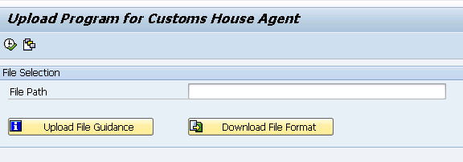

Frame title should be File selection and field label as File Path.

* On click of button upload File Guidance, pop up should show all the fields and its sample values to be uploaded. Field names must follow title case, no abbreviations should be there and alignment should be proper.

**Webdynpro ABAP and FPM Developments:**

* All the webdynpro developments must be implemented on FPM.
* All the input fields should be displayed right aligned.
* All the developments should follow following colour format for groups –

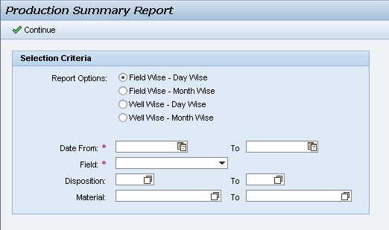.

* Personalization button should not be there on any screen the same is allowed on ALV toolbar only.
* In custom F4 help description should also be displayed along with the field.
* Custom buttons should not be emphasized (use only standard).
* Do not use separator between the custom buttons.
* Attach suitable / standard icons to the custom buttons and icons used for buttons should be cross verified with UI guidelines document. (* Standard icons of respective FPM components must be used)
* No abbreviations are allowed anywhere in the developments.(*Except for button labels but button tool tip should have complete long form )
* Explicit download functionality as well as button for the same should not visible on screen.
* Screen field labels must be title case i.e. first letter of every word capital except for connecting words as for, by, the, from. (e.g. Port of Dispatch) But if the same words are first or last word of label then title case must be followed for it. (e.g. Created By)
* Amount and Quantity fields should always be displayed right justified while all other fields should be left justified.
* Tool Tip is to be given for all the field labels for all Input Fields/ALV Output /Table output and buttons on the screen in complete long forms.
* If any improper field description or label is coming from any data element then description in data element is to be changed.
* Messages in all the message classes, text elements and constants to be corrected as per guidelines, Follow sentence case for all the messages.
* Provide description for all the fields for which descriptions are available like Plant, Storage Location, Material Number, Document Type, Company Code etc. in output. Also populate description for such fields in selection screen beside these fields.
* We can provide display variant to user either user is interested to see only that code only or description only or both.
* Please provide Unit of Measure for quantity and Currency for Amount fields in separate column if the same is different for different line items, If the Unit of Measure and Currency are same

For all the line items the same can be given in column header of that field

e.g. **Billed Amount (in INR)                  Produced Quantity (in SM3/BBL)**

* For any file upload file options please refer **Upload Program** section of document if the same is coming as a pop up, while it is to be given on screen the required buttons of Upload Guidance and Download File Format is to be given on toolbar as cannot be given on screen in FPM.
* Do not use words “Please/Kindly/Request you” at any place.

**Screen shot for upload programs:**

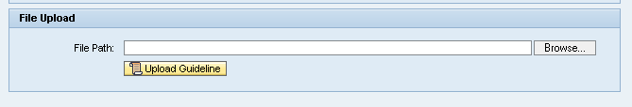

**Screen shot for ALV programs:**

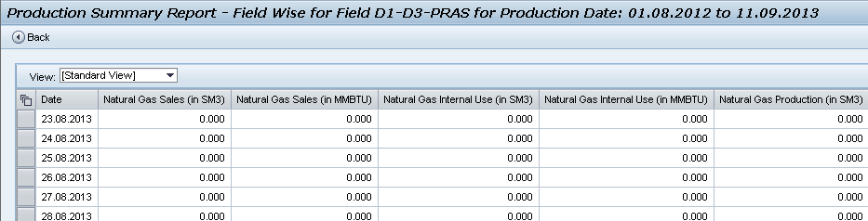

No button is required in the ALV layout, if there are many fields, then gives the View option otherwise it is also not required.

 back button should be used as shown in the screenshot for all WDA objects.

By Default buttons  appear on the ALV layout, kindly keep them as it is.

**For displaying Two ALVs on the same screen:**

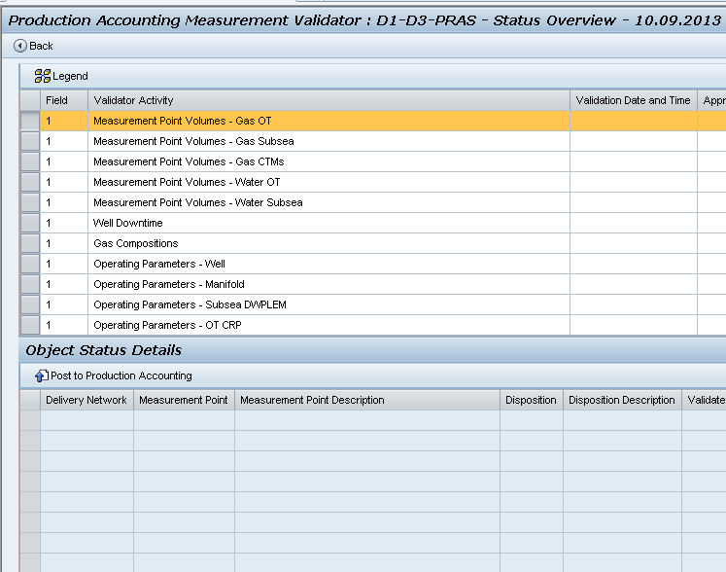

Give either checkbox or normal select all/Deselect all option in ALV as given in the screen shot below marked in red.

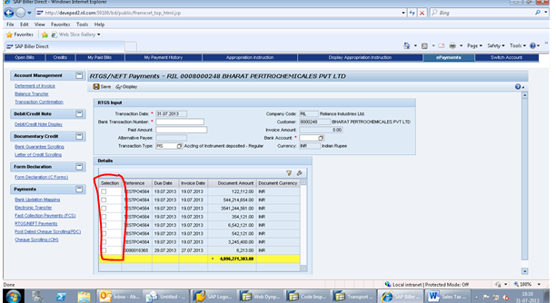

To provide user defined buttons for an ALV, please place them on the Menu bar.

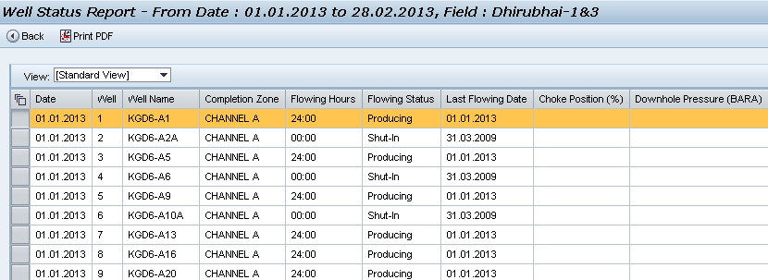

For complex ALV outputs, please refer the screen shot below, here we have column inside a column.

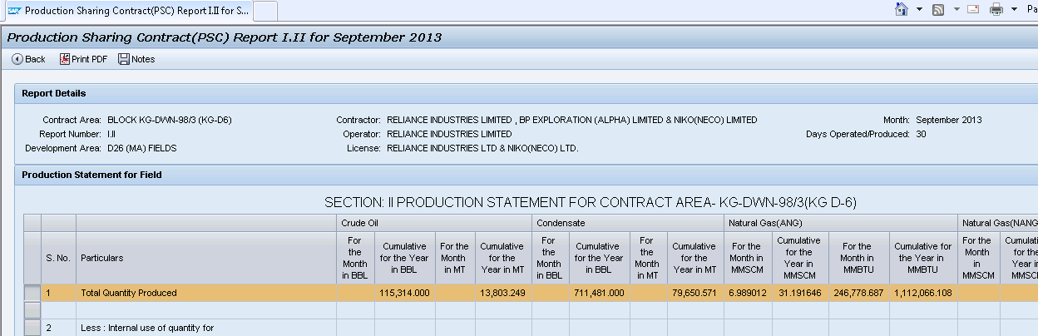

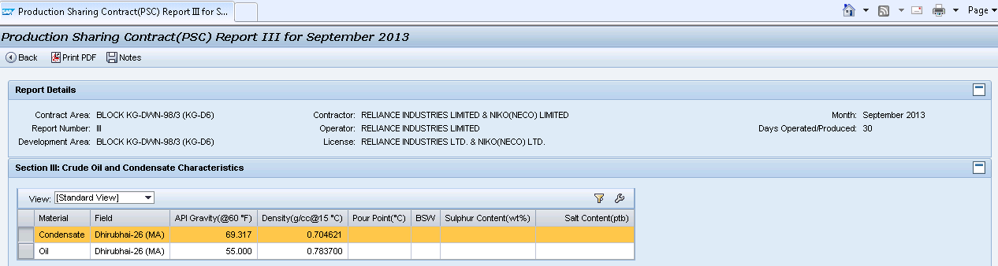

**Some More Useful Screenshots:**

**Bank Update Mapping**

**Component Name:** ZFCA_BANK_DETAILS_UPDATE

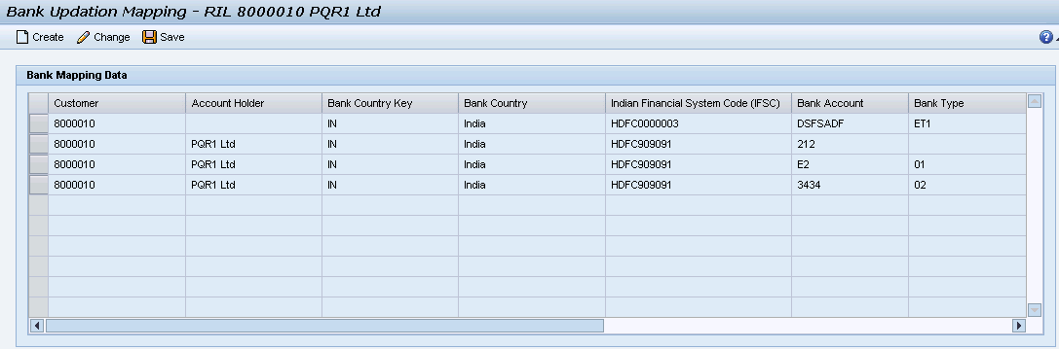

**Create Bank Mapping**

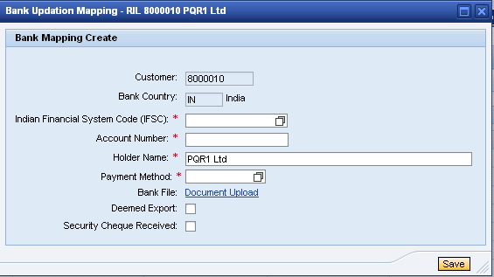

**Fast Collection Payments (FCS)**

**Component Name: ZFCA_PAY_ADV_NOT_FCS_FPM**

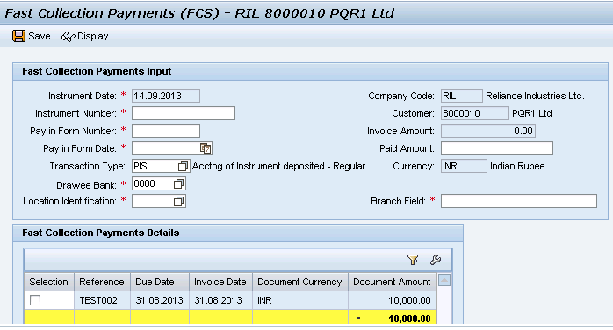

**Display View**

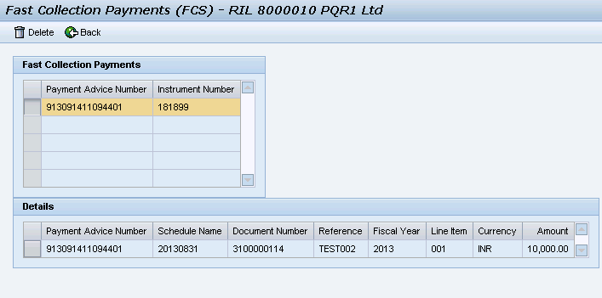

**RTGS/NEFT Payments (Real Time Gross Settlement Input)**

**Component Name: ZFCA_PAY_ADV_NOT_RTGS**

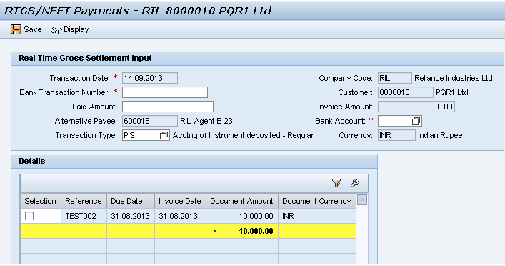

**Display View**

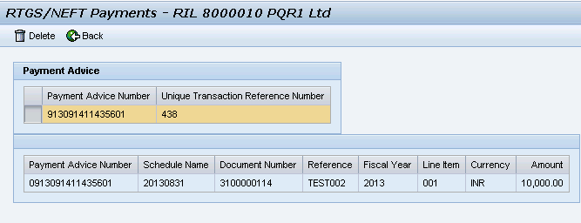

**Post Dated Cheque Scrolling (PDC)**

**Component Name: ZFI_PDC_SCROLL**

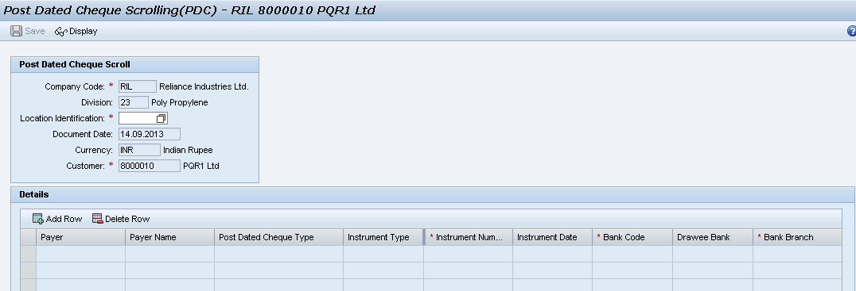

**Display View**

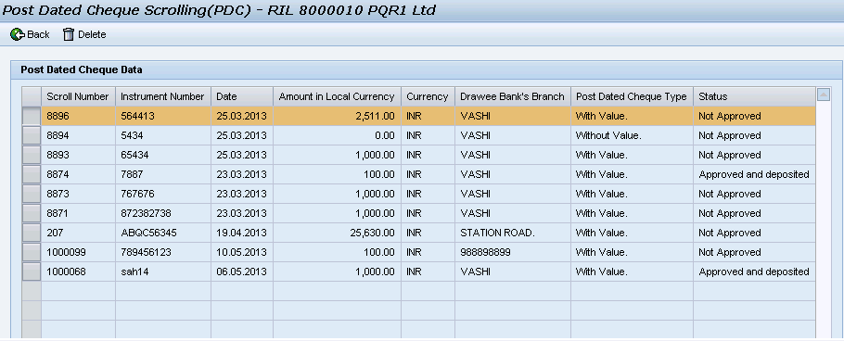

**Cheque Scrolling (CIH)**

**Component Name: ZWEB_COL_INST**

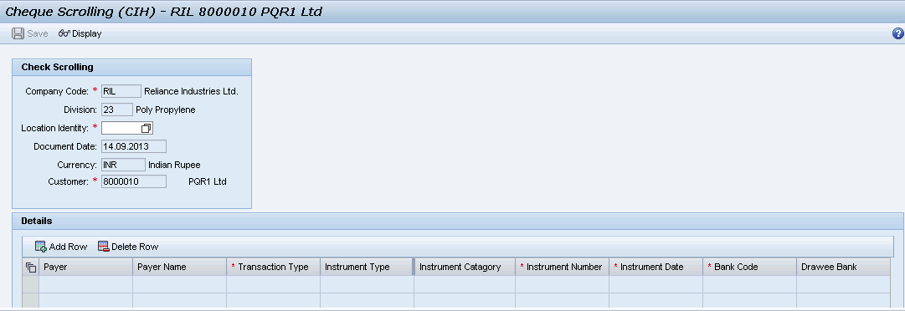

**Display View**

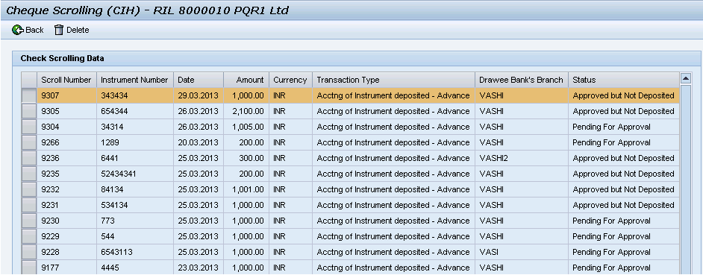

**Transaction Confirmation**

**Component Name: Z_CUSTOMER_DETAILS**

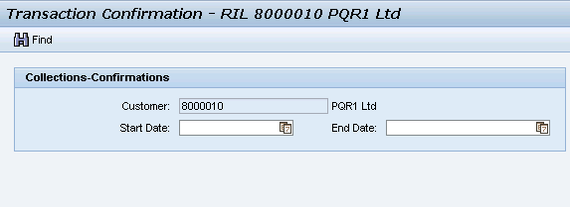

**Reply View for Transaction Confirmation**

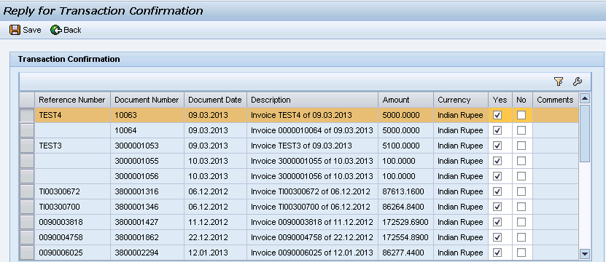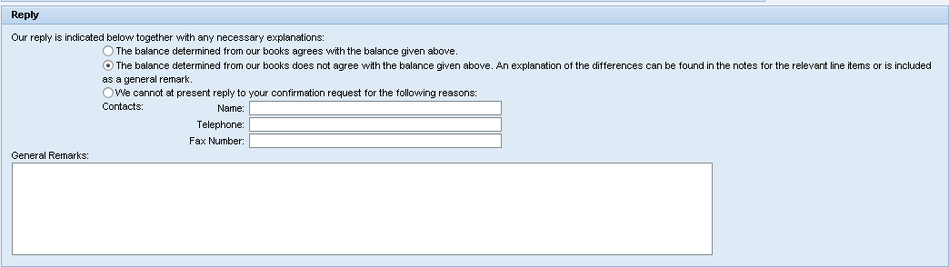

**Bank Guarantee Scrolling**

**Component Name: ZFCA_BG_SCROLLING**

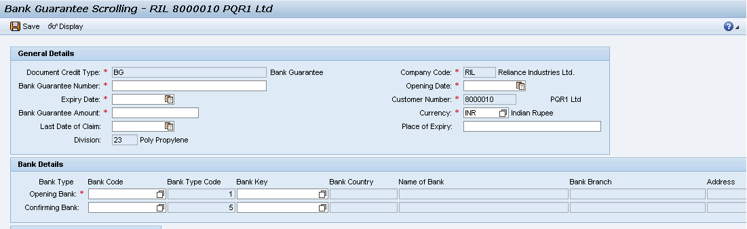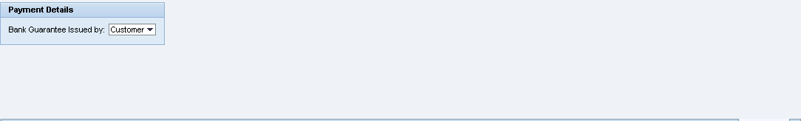

**Display Screen for Bank Guarantee scrolling**

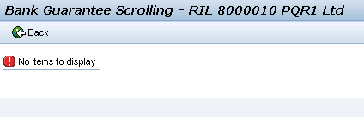

**Letter of Credit Scrolling**

**Component Name: ZFCA_LC_SCROLLING**

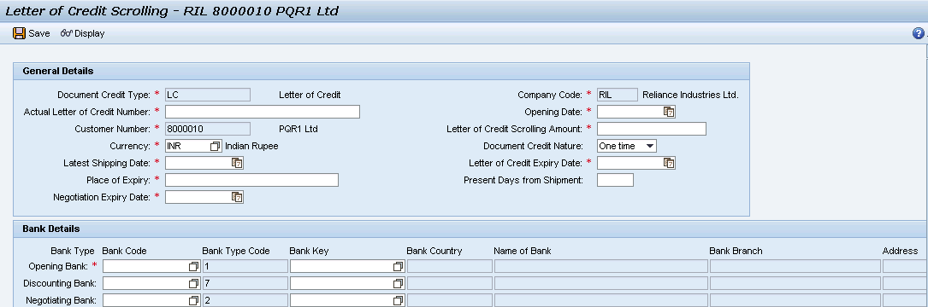 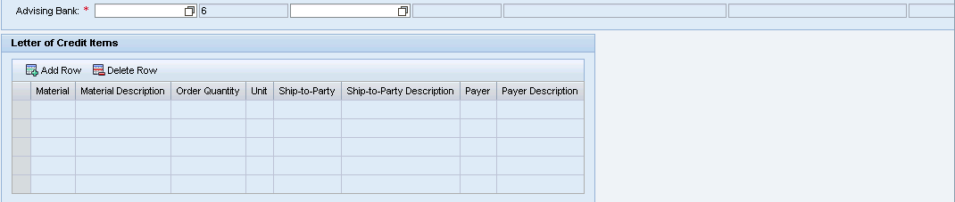

**Display View for Letter of credit scrolling**

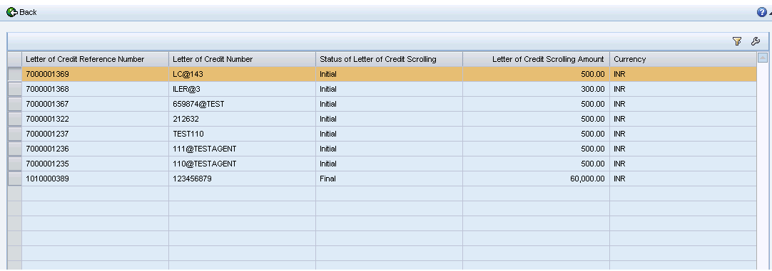

**Form Declaration**

**Component Name: ZFCA_DEC_SCROLL**

**Initial Screen**

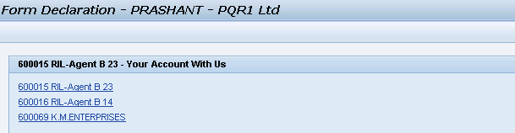

**List of forms Scrolled**

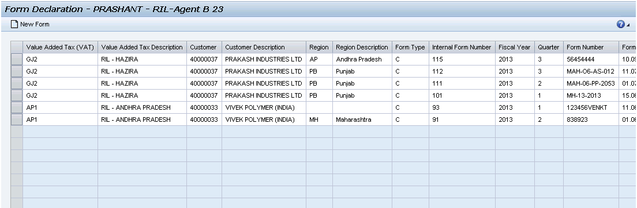

**Create a new form**

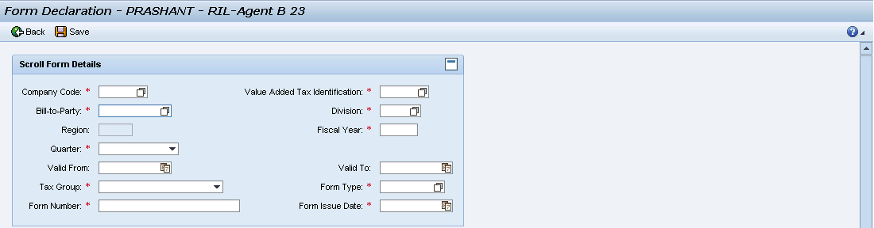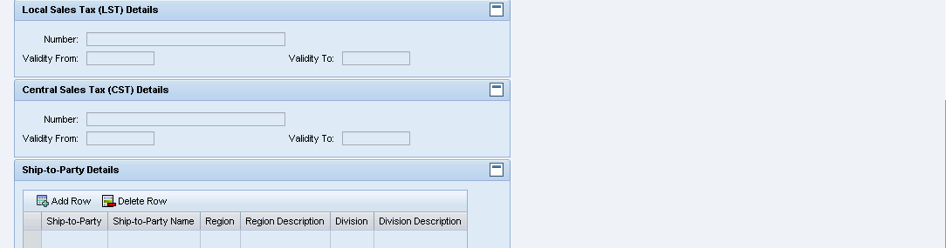

**Credit/Debit Note**

**Component Name: ZFCA_BILLER_DIRECT**

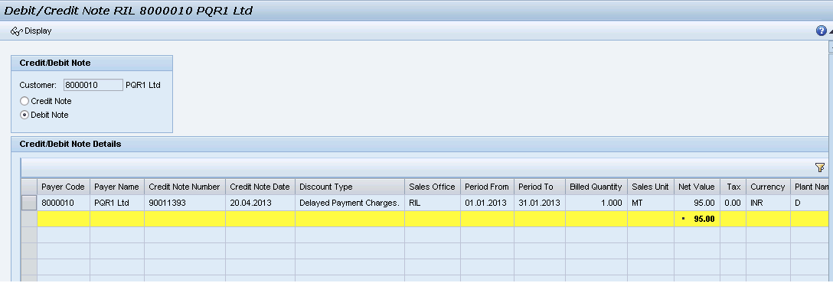

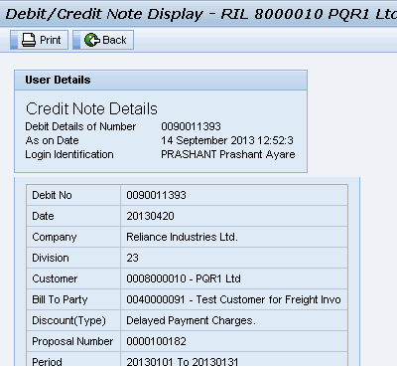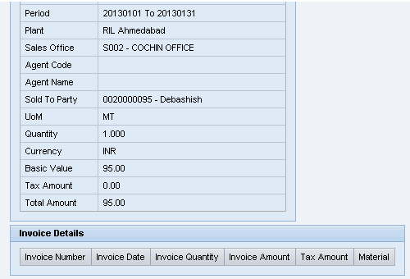

**Commission of Invoice**

**Component Name: ZFCA_COMMISION_INVOICE**

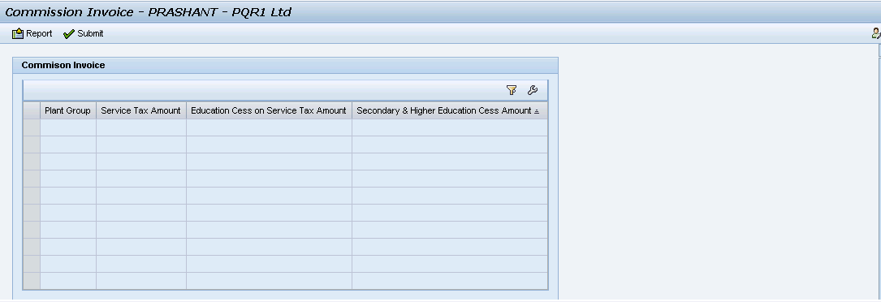

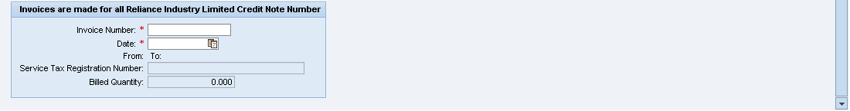

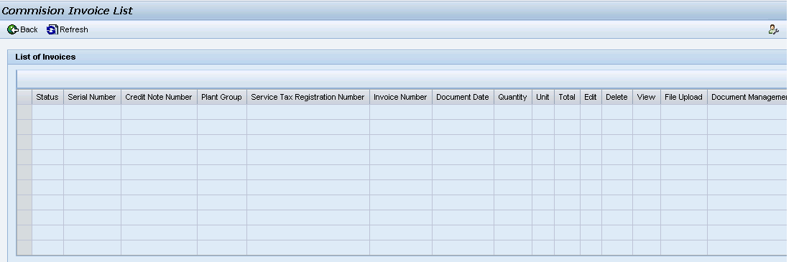

**Balance Transfer**

**Component Name: ZFCA_BAL_TRANS**

**Display View**

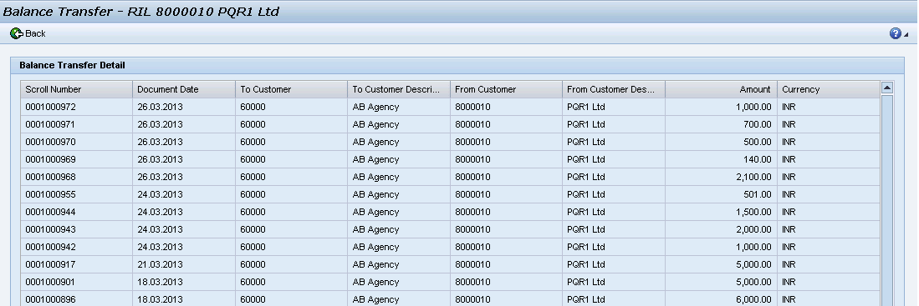

**Down Payment Create**

**Component Name: ZFCA_DOWN_PAYMENT_CREATE**

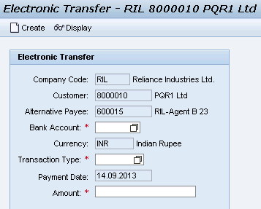

**Create with PIS**

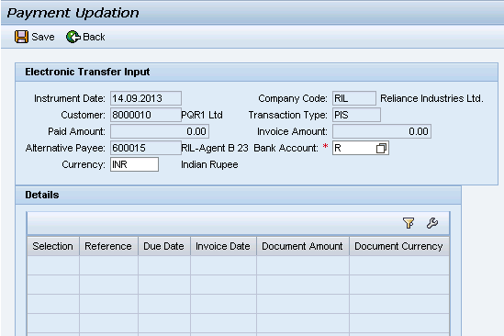

**Display**

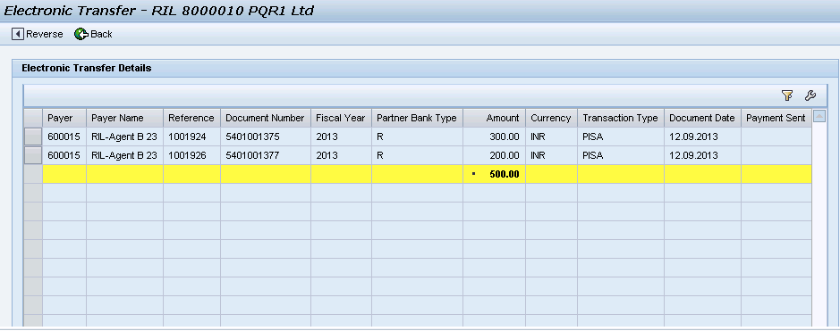

**Some more screen shots for your reference:**

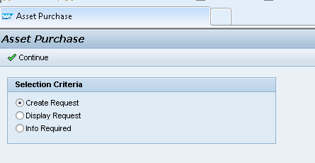

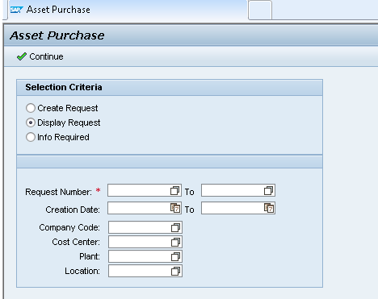

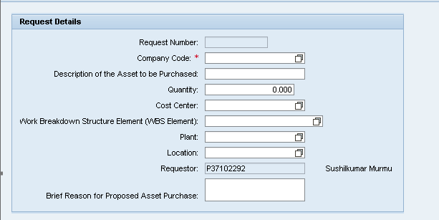

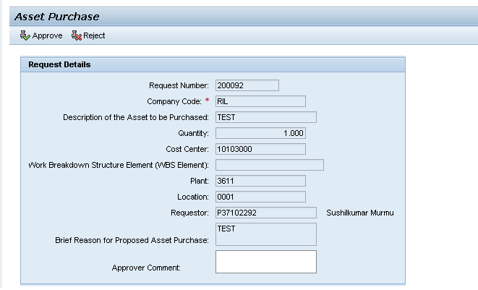

**Screen shot for form creation:**

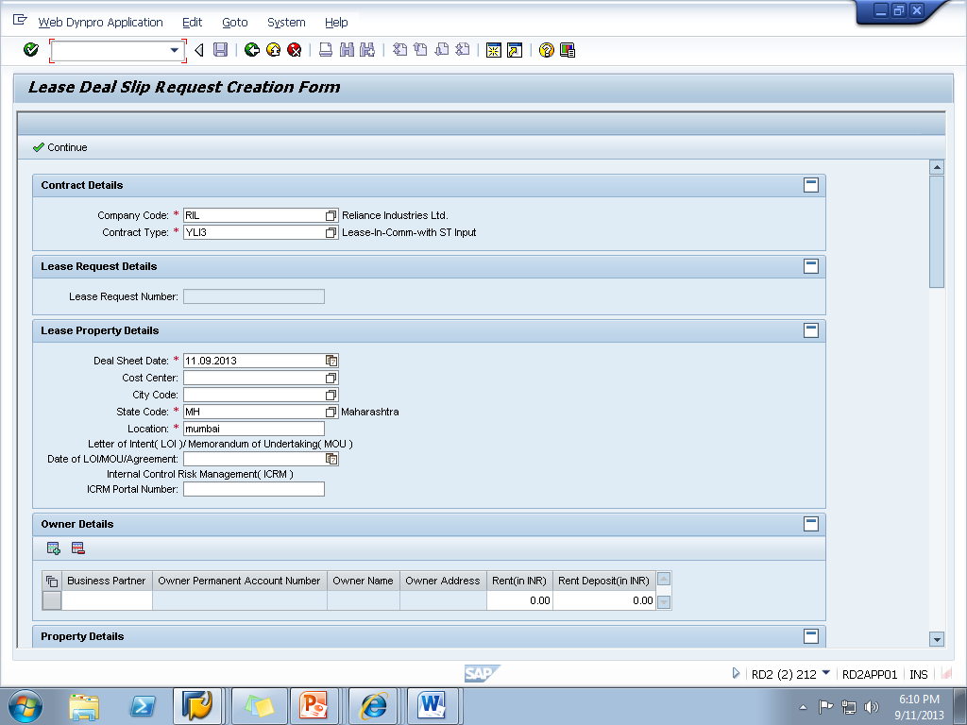

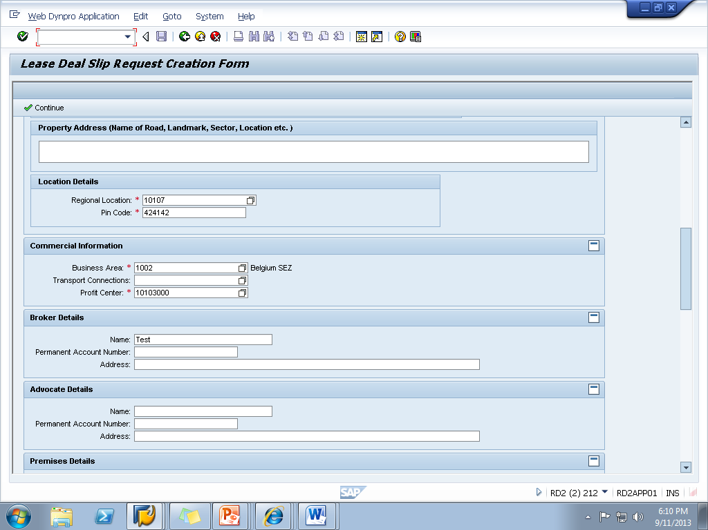

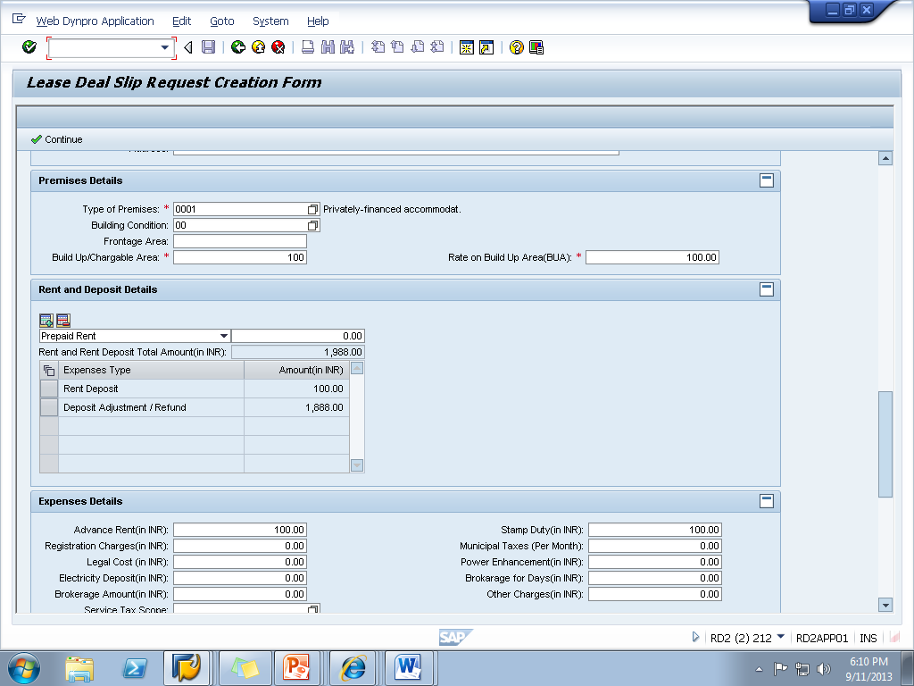

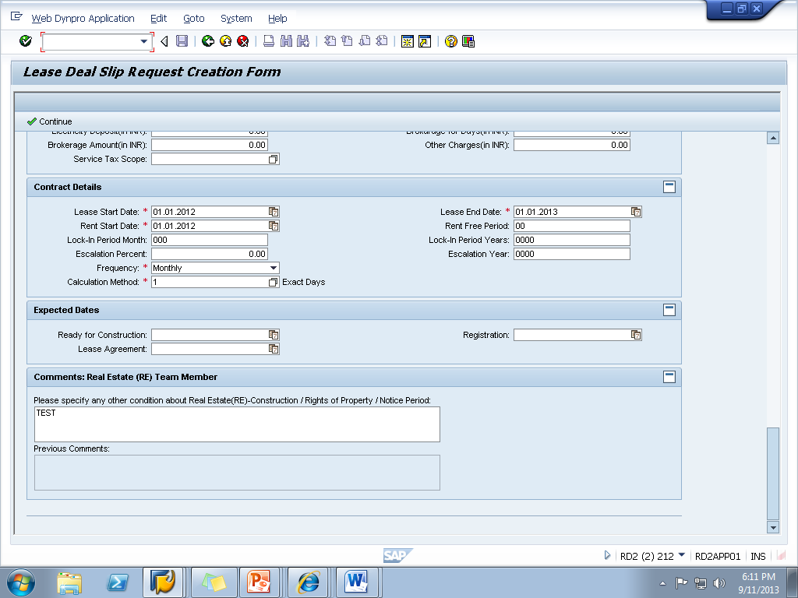

**Some more screen shots for your reference:**

**Description:** Asset Transfer

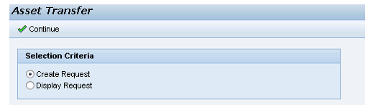

**Creation Level**

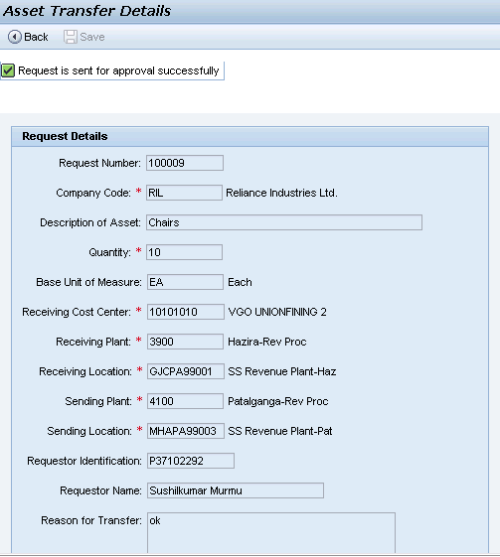

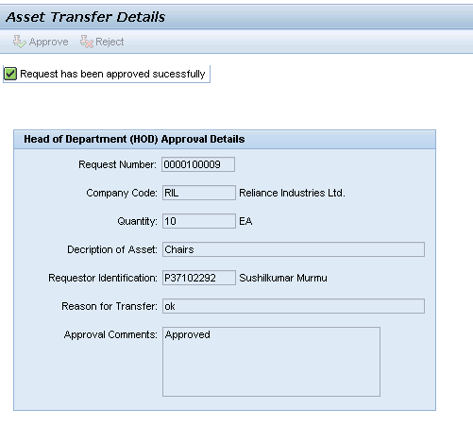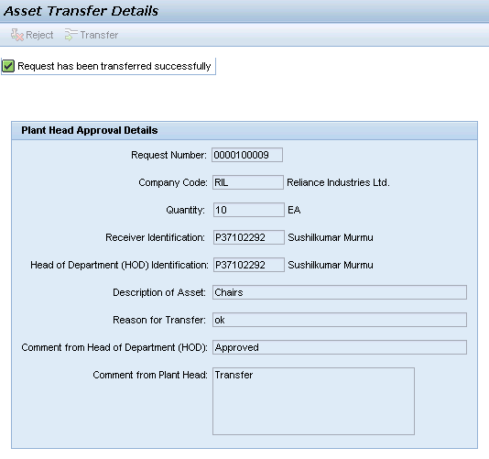

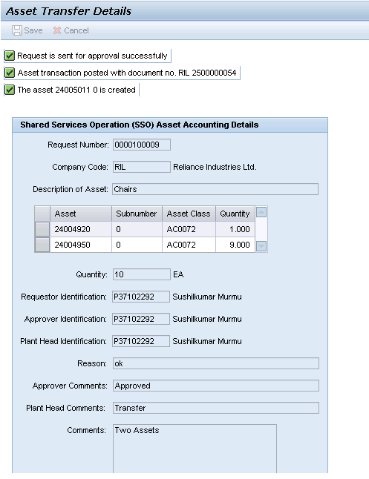

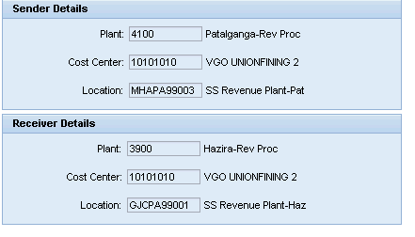

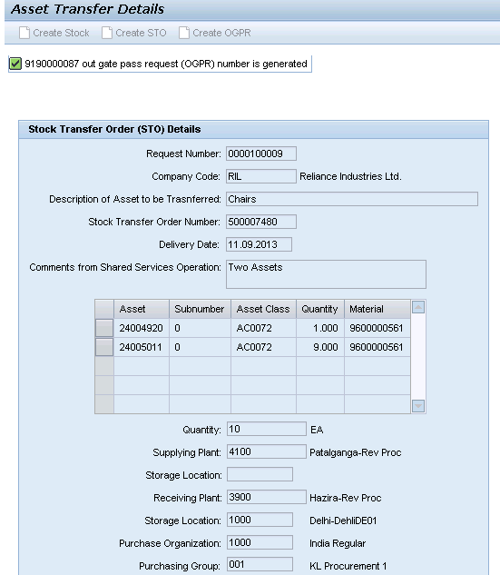

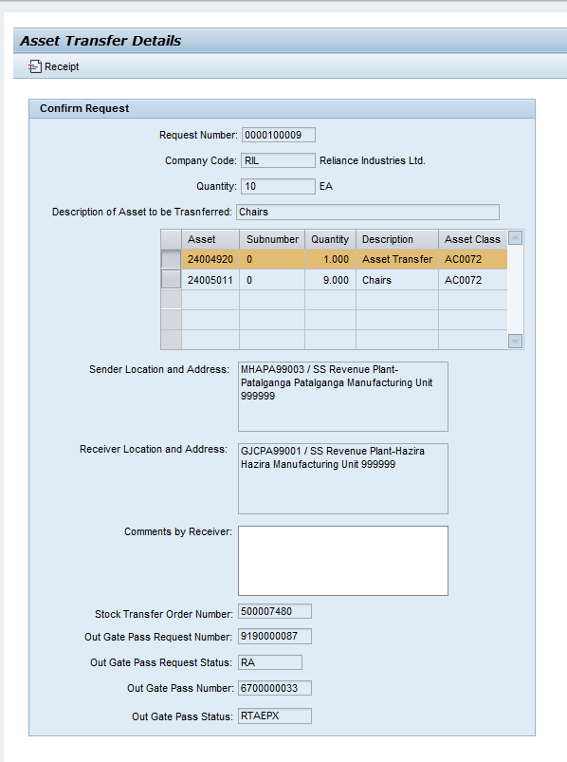

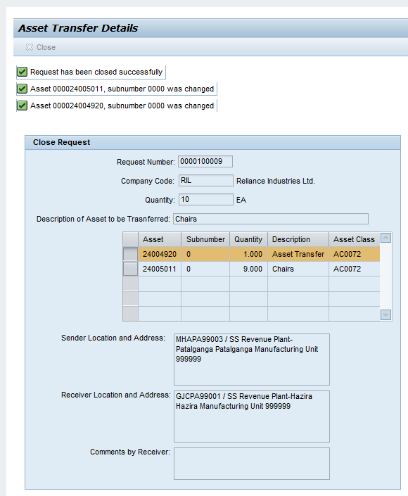

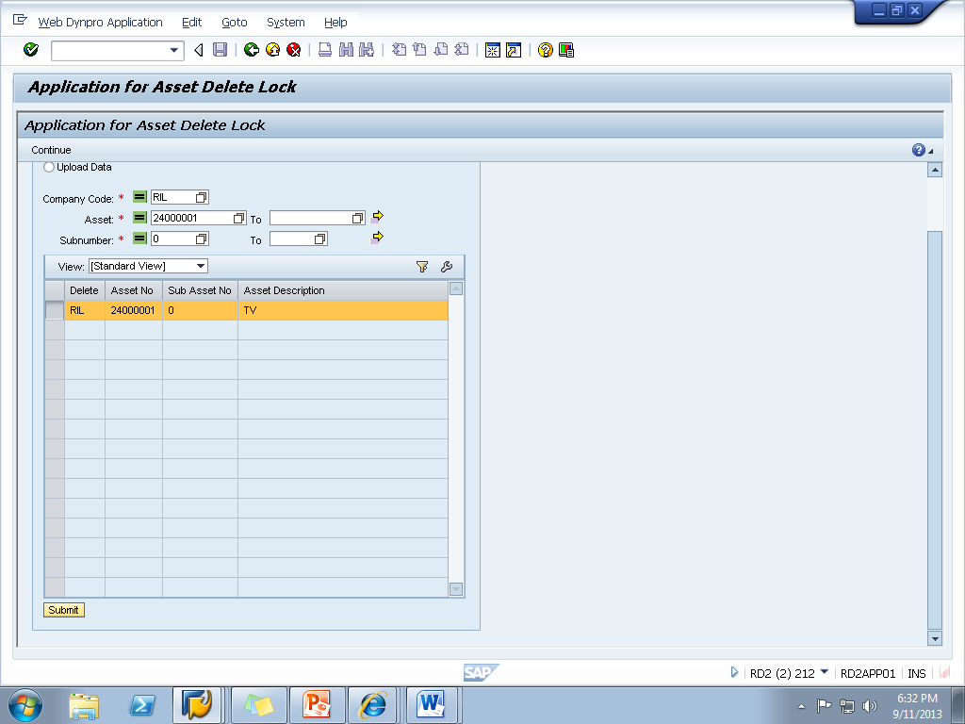

**Description:** Custom fields in SAP PPM Portfolio Item Level

**Component Name:** ZPTC_ITEM_DATA

Nwbc (T code )🡪 SAP_BPR_PPM 🡪Portfolio Management🡪Portfolio items🡪Select any Item🡪Select Custom item Tab

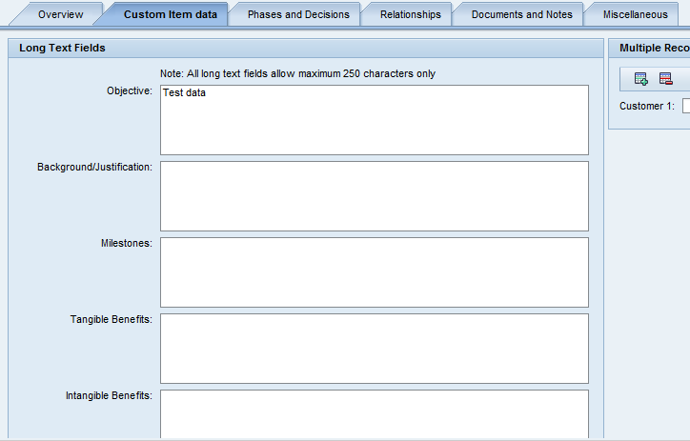

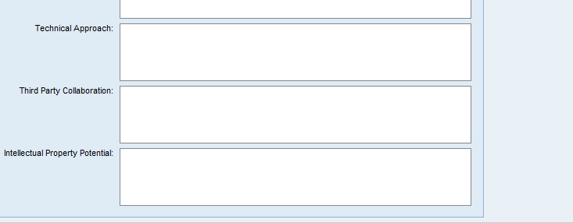

**Description:** Custom fields in SAP PPM Project Phase Level

**Component Name:** ZPTC_PHASE_DATA

Nwbc (T code )🡪 SAP_BPR_PPM 🡪Project Management🡪Select any Project🡪Select Phase Type🡪Select Phase Detail tab

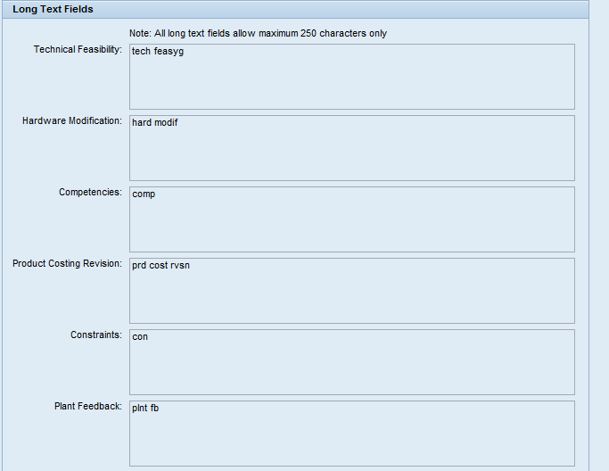

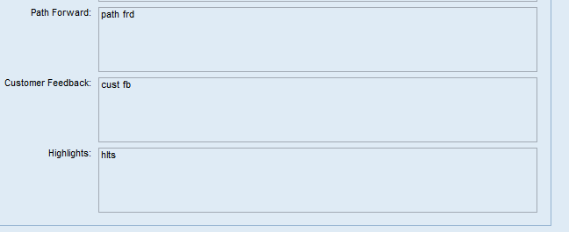

**Description:** NPV Calculation

**Web Dynpro Enhancement Name:** ZPTC_ENHO_NPVCAL

Nwbc (T code )🡪SAP_BPR_PPM🡪Portfolio Management🡪Portfolio items🡪Select any Item🡪Over View Tab🡪Financial Information tab

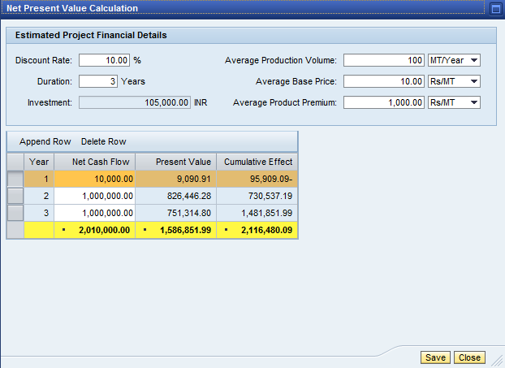

**Description:** Process Loss Calculation

**Web Dynpro Enhancement Name:** ZPTC_PROCESS_LOSS_CAL

Nwbc (T code )🡪nwbc🡪Recipe Development🡪Recipes Tab🡪Change Recipe🡪Select any Recipe🡪Click on Formula Tab 🡪Click on Alt. UoM button

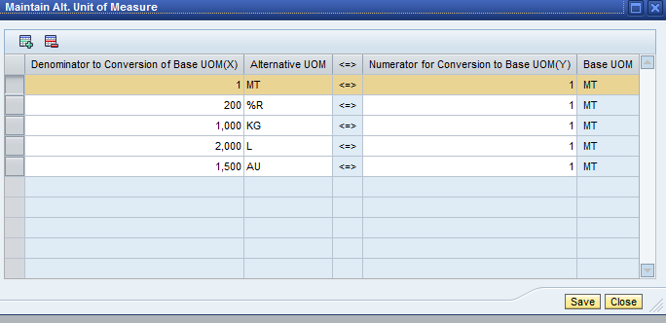

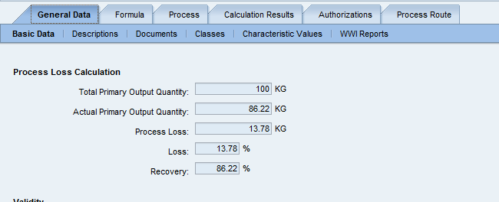

**Track** –APO

**Webdynpro component** --ZDP_EXTERNAL_AGENTS

**Description** - Collaborative demand planning.

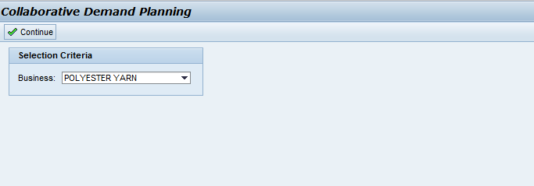

**After click on continue button.**

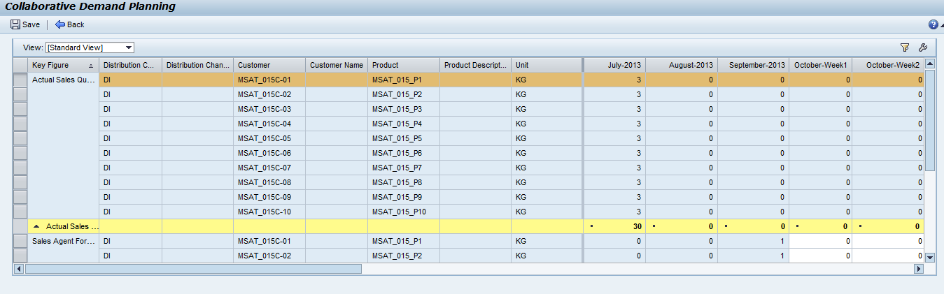

**Webdynpro component -** ZPTC_ORDER_STATUS_REP

**Description:** Order status report

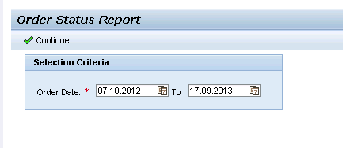

**By clicking on continue.**

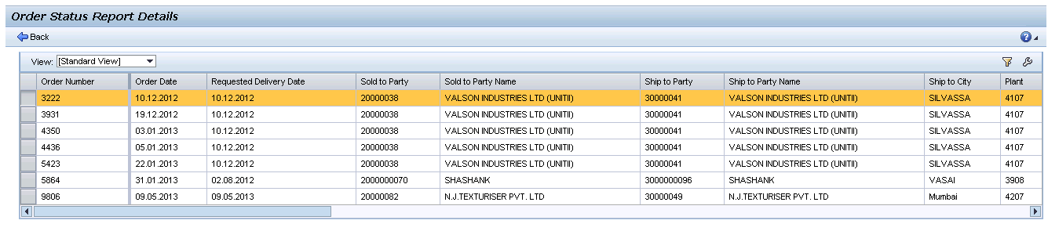

**Webdynpro component --** ZPTC_INVOICE_DETAIL_REP

**Description** : Invoice Details Report

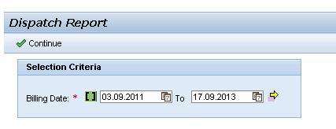

**By clicking on continue.**

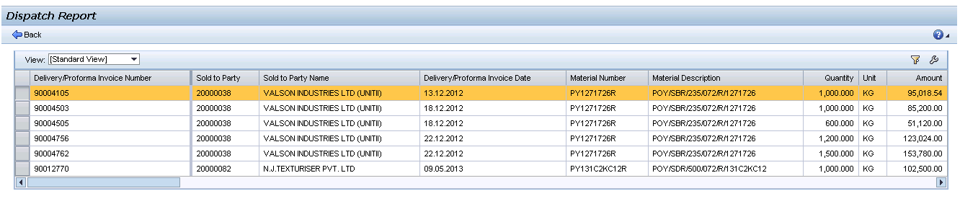

**Track - ENP**

1. **PSC Reports and Forms**

Component: ZPRA_PSC_REPORT_AND_FORMS

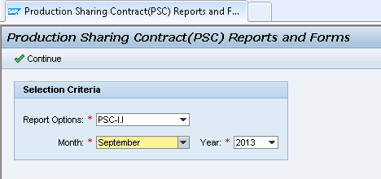

PSC -I.I, PSC I.II and PSC II.I

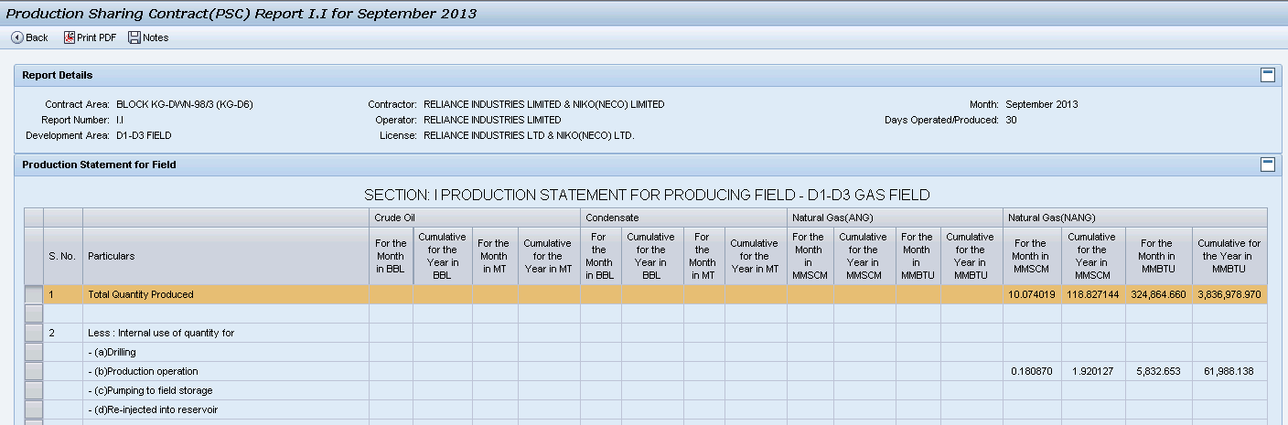

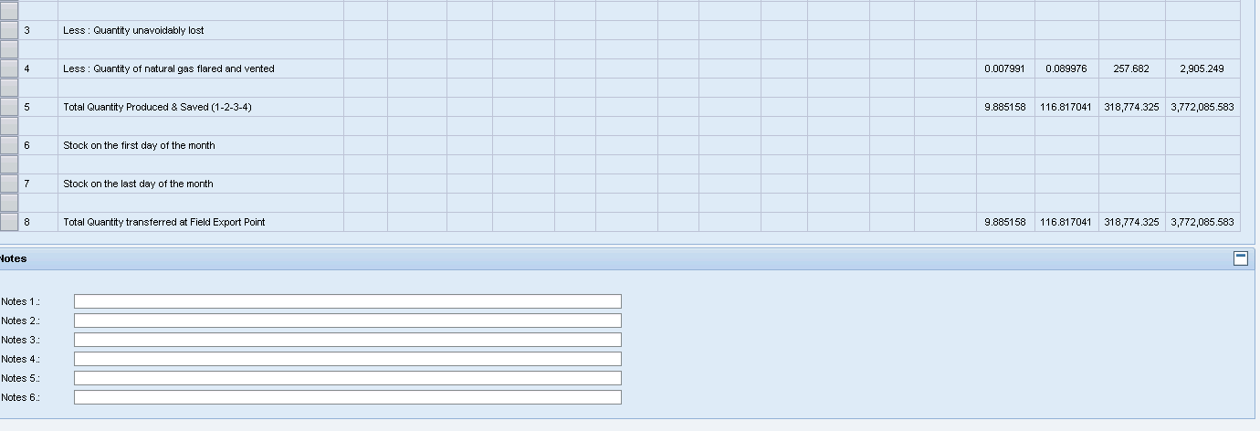

PSC-III report

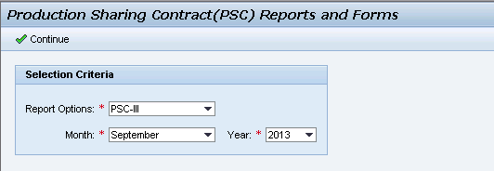

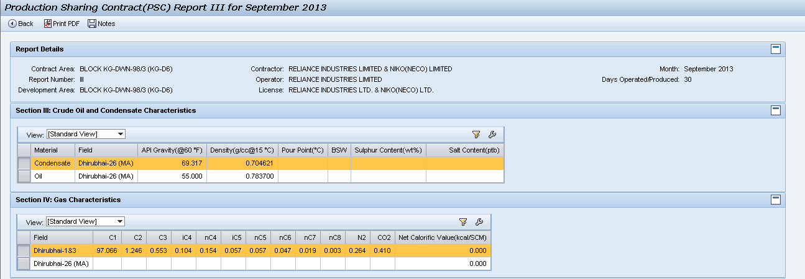

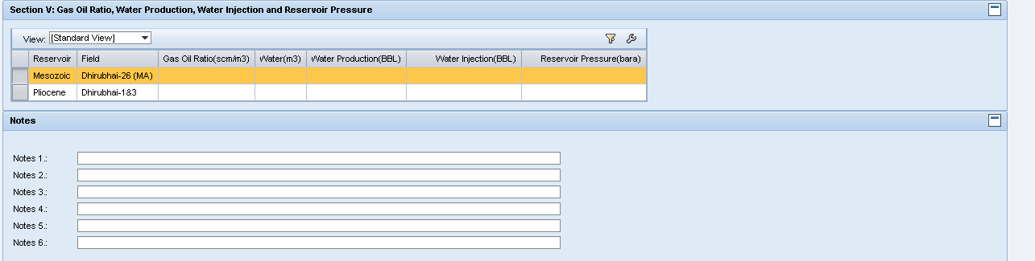

**Buttons:**

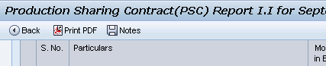

PDF form gets displayed when “Print PDF” button is clicked.

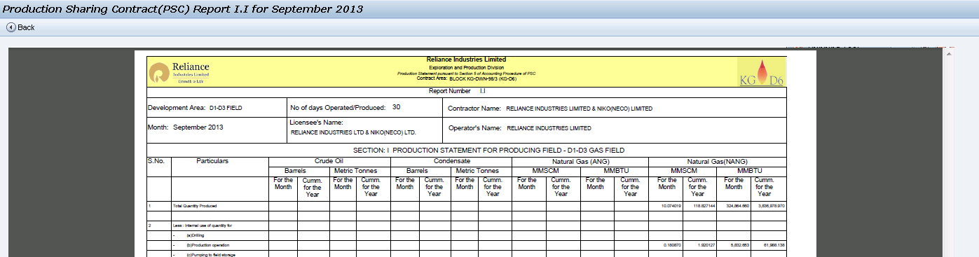

When “Save Notes” button is clicked, then following confirmation message is displayed

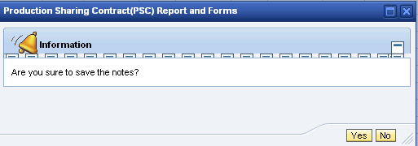

The notes entered on the screen gets saved with a message

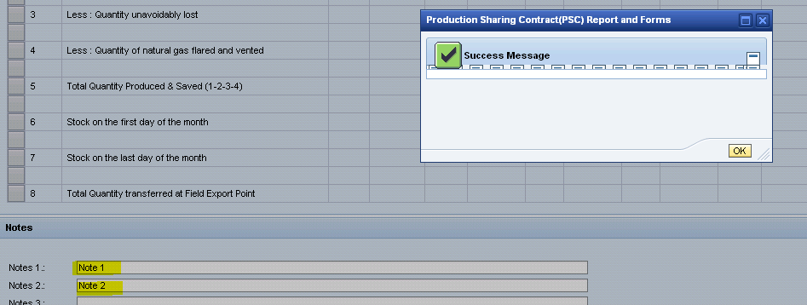

1. **Production Summary Report**

**Component:** ZPRA_PROD_SUMMARY_REP

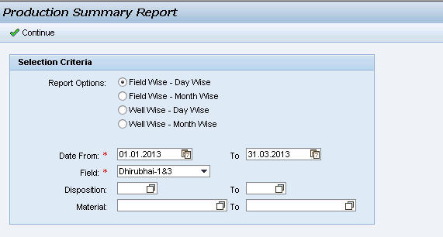

**Field wise day wise report**

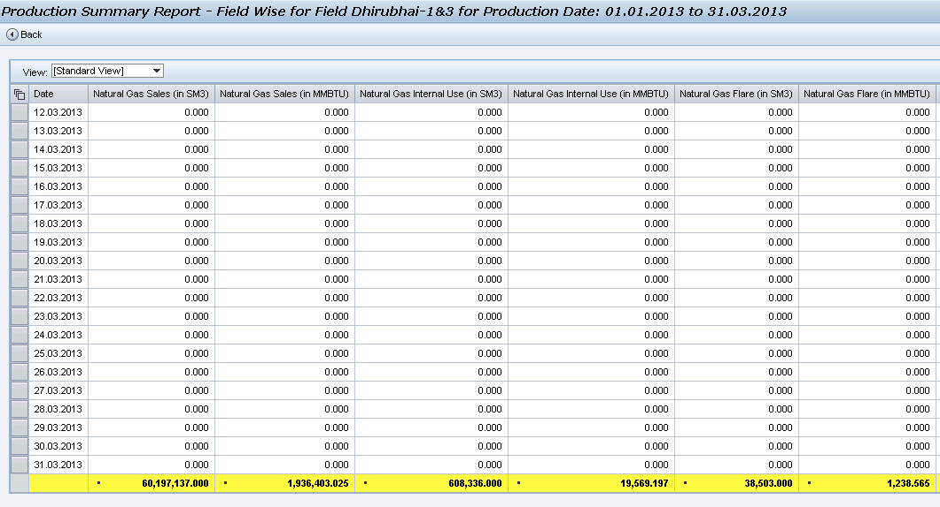

**Field wise month wise report**

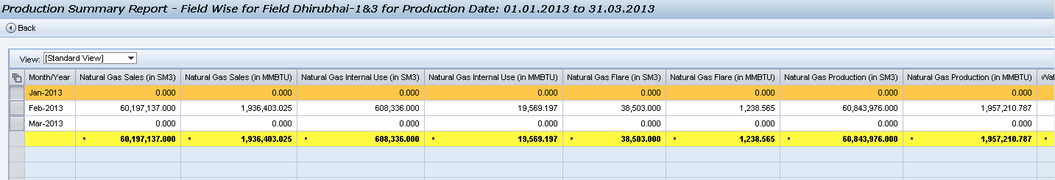

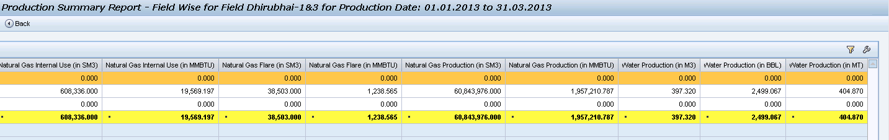

**Well wise day wise report**

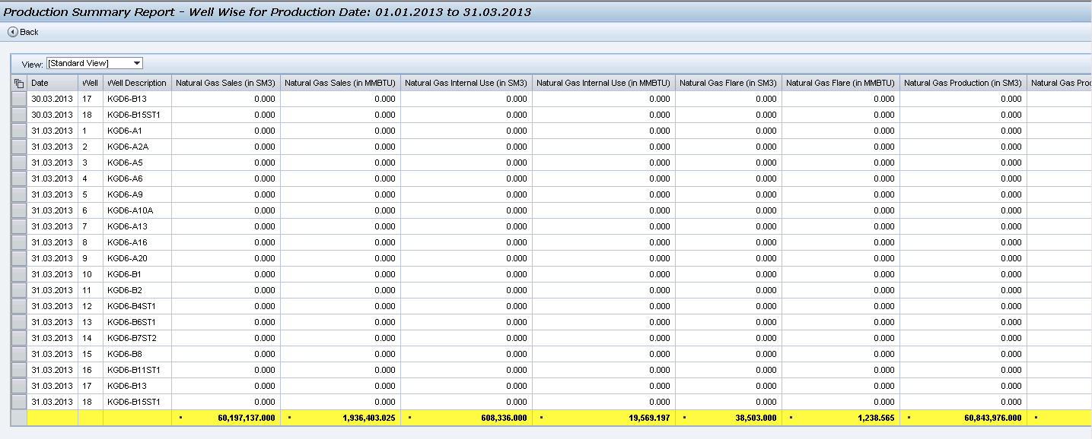

**Well wise month wise**

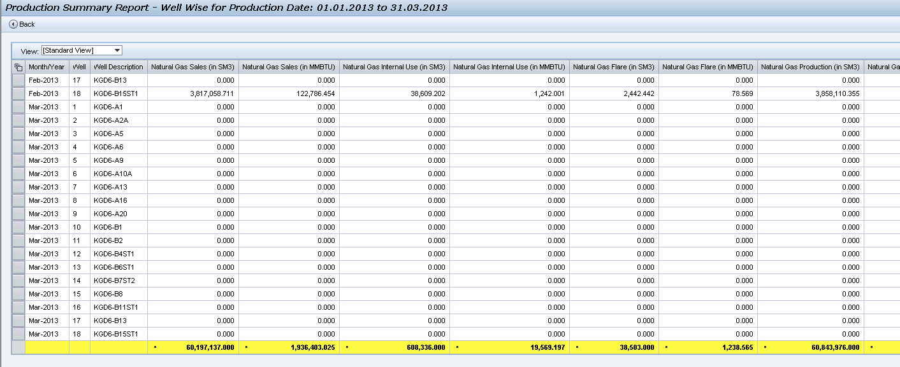

1. **Management Report**

**Component:** ZPRA_MANAGEMENT_REPORT

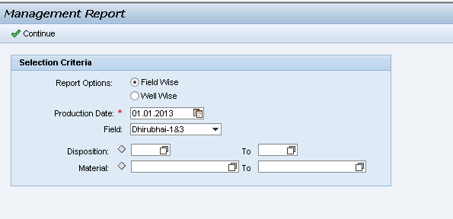

**Field wise report**

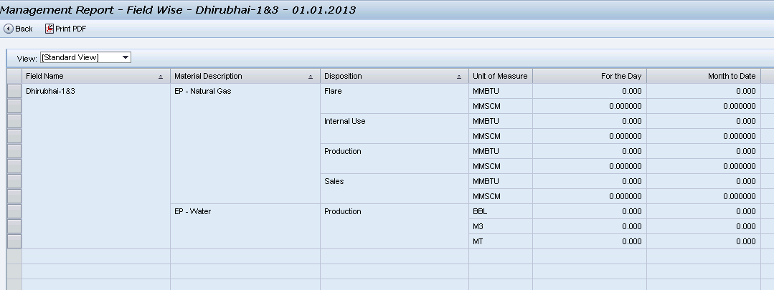

**Well wise report**

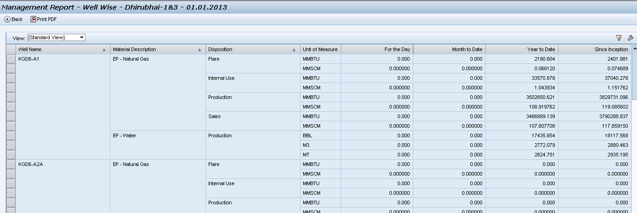

**Print Button**



**Form displayed on clicking the button**

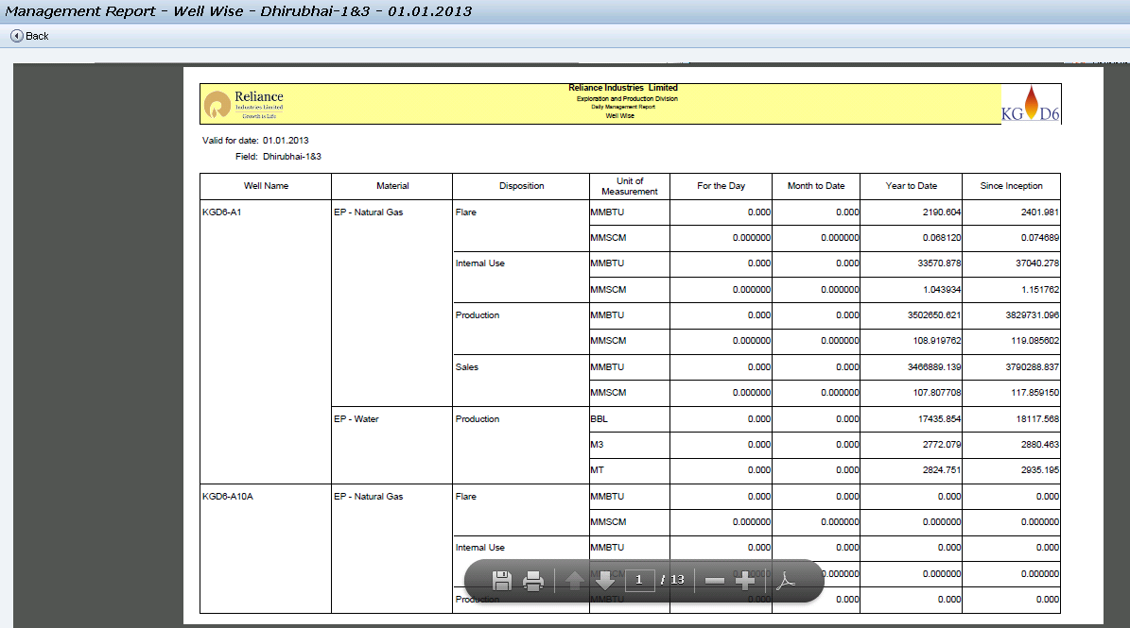

1. **Planned production**

**Component:** ZPRA_PP

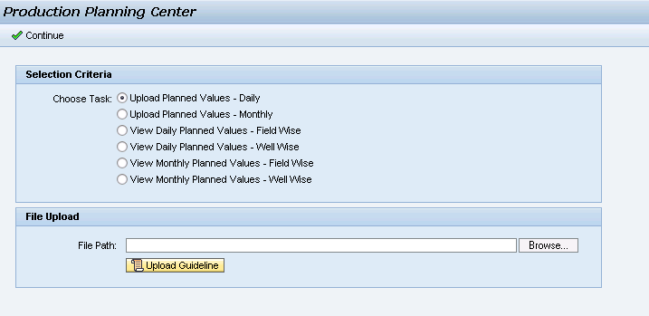

**Upload Guidelines button**

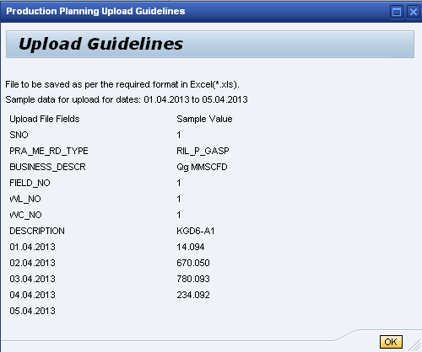

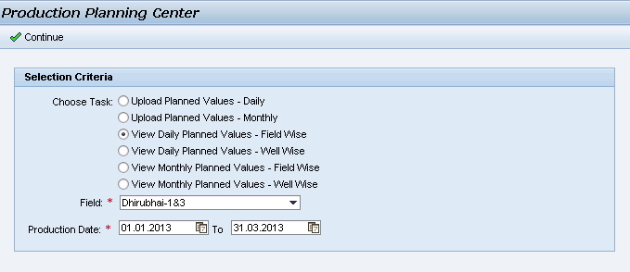

**Field wise Daily**

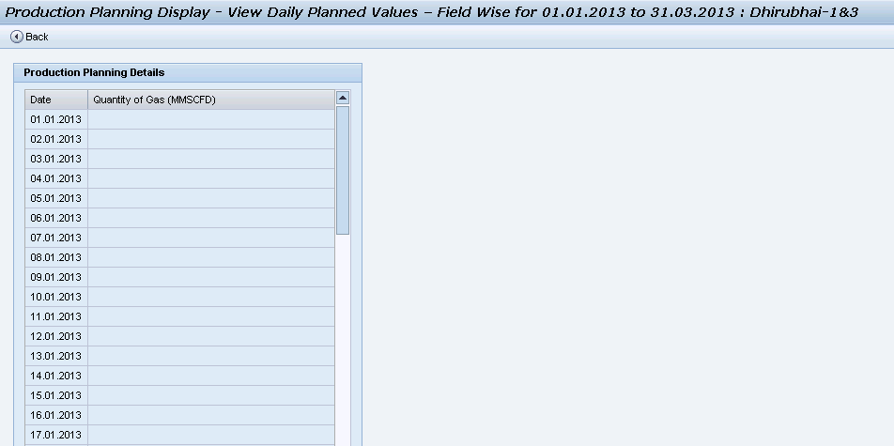

**Well Wise Daily**

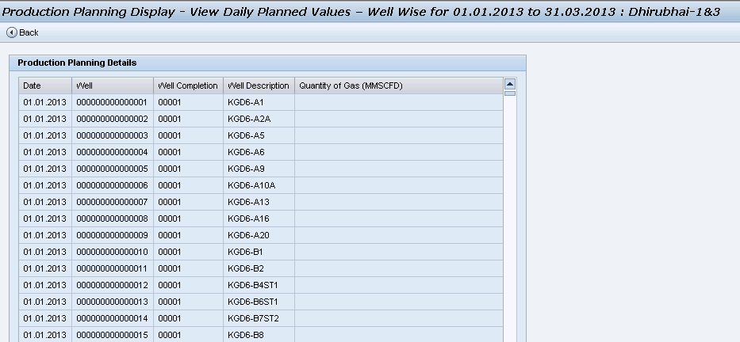

**Field wise monthly**

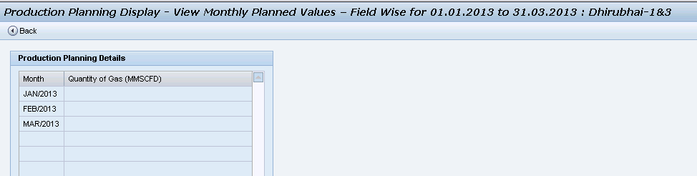

**Well wise monthly**

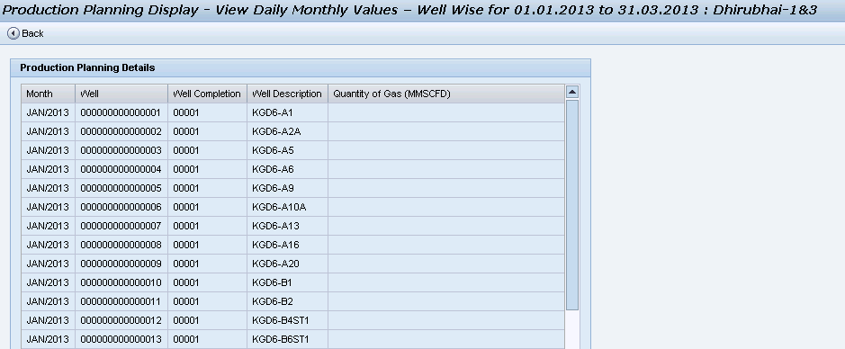

1. **Validator**

**Component: ZPRA_VALIDATOR**

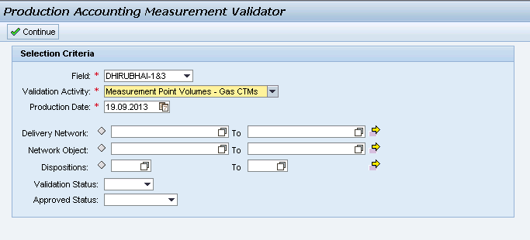

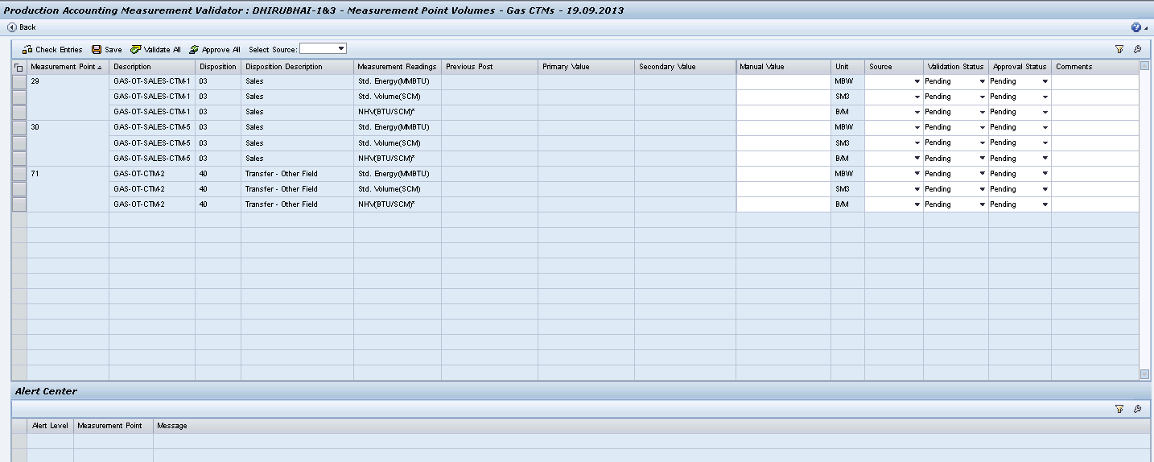

**Messages are displayed on each button on clicking Check Entries**

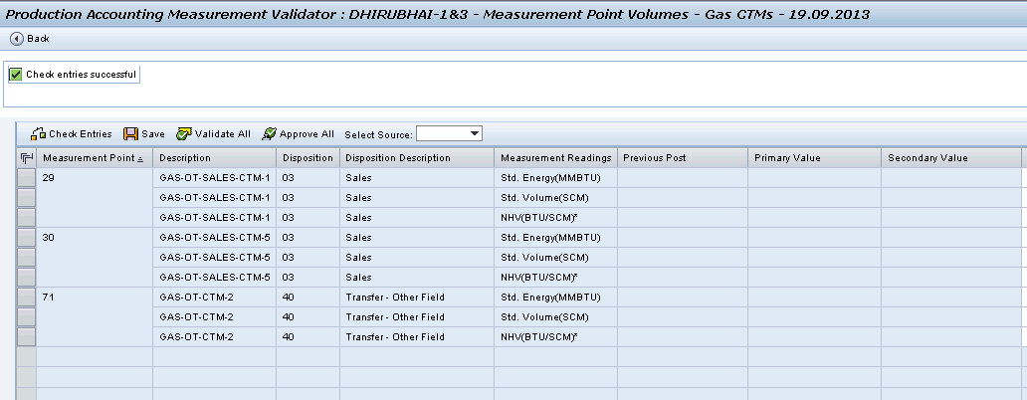

**Validation message on clicking check entries**

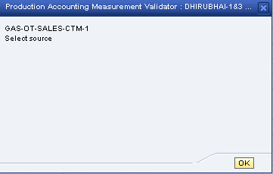

**Status overview screen:**

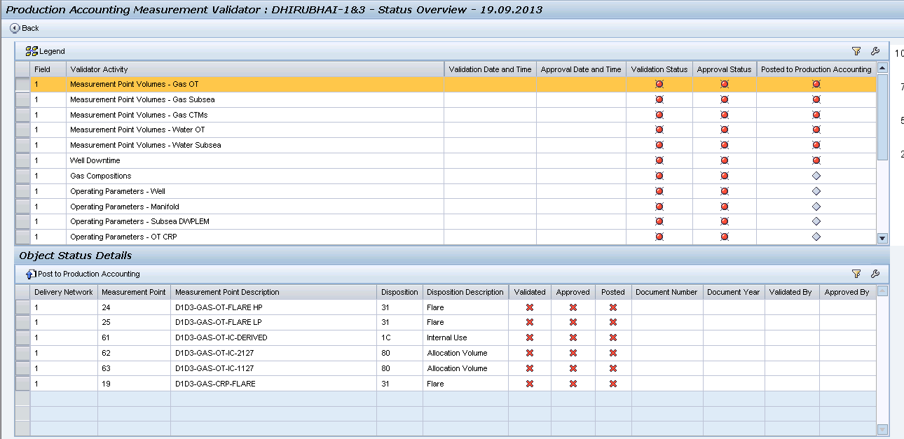

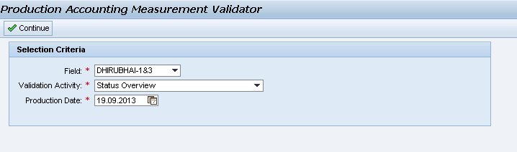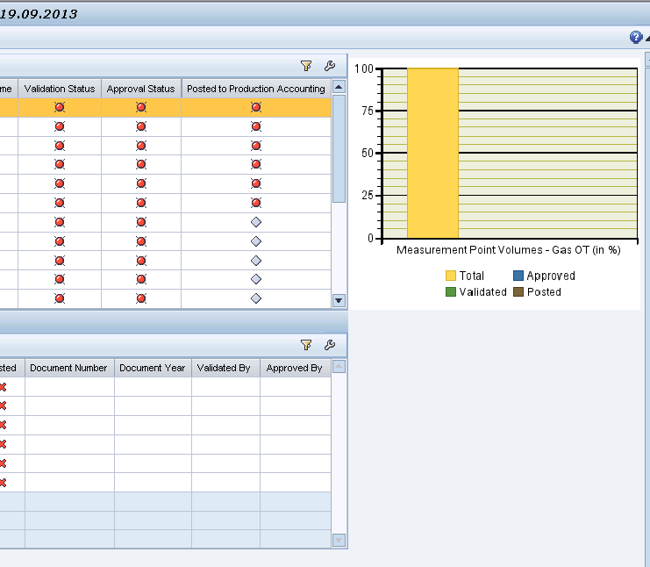

**Clicking on Legends Button gives the pop up:**

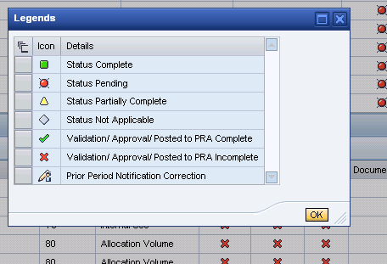

**Messages displayed on clicking the Post to PRA button**

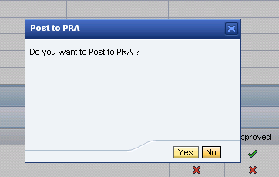

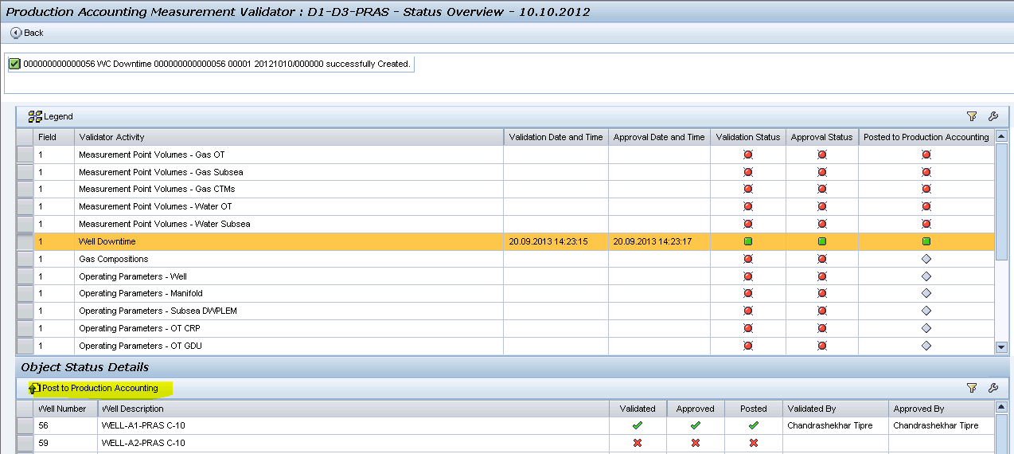

1. **Well Wise report**

**Component:** ZPRA_WELL_WISE_REP

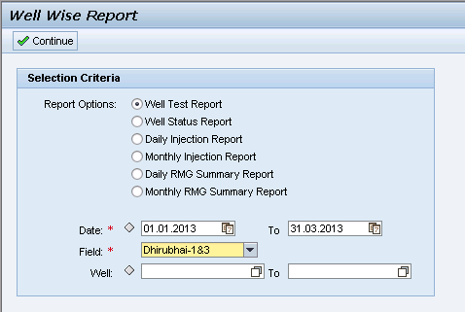

**Well Test Report:**

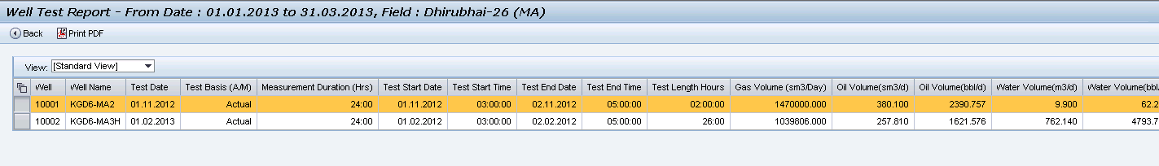

**Well Status Report:**

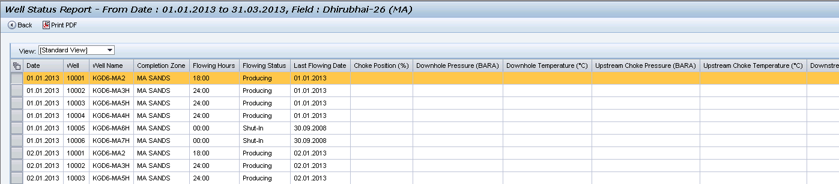

**Daily Injection Report**

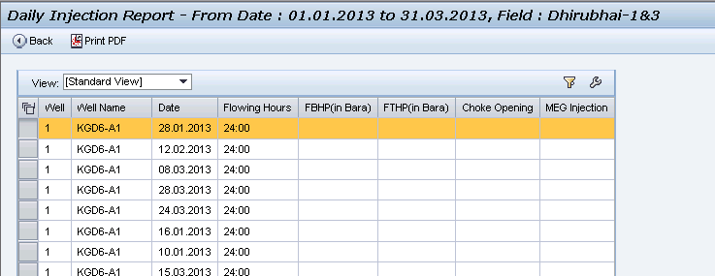

**Monthly Injection report:**

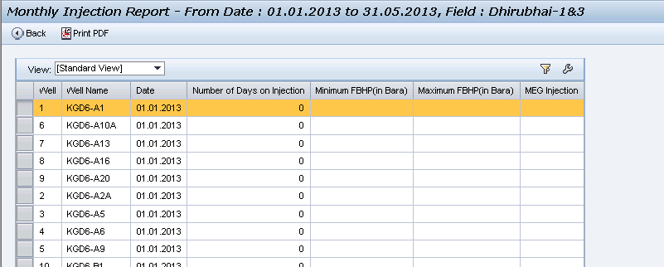

**Daily RMG report**

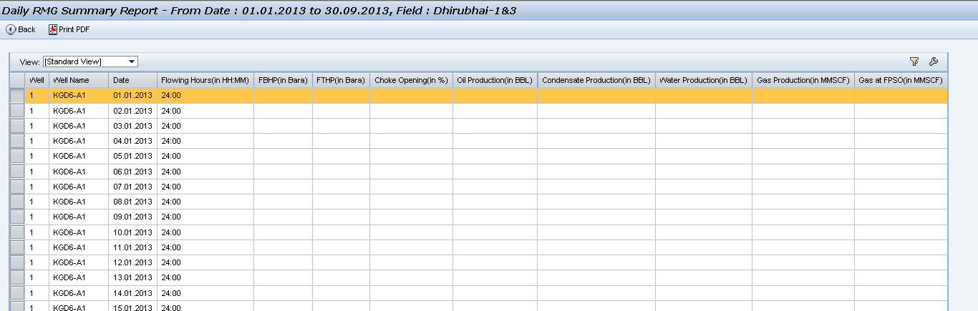

**Monthly RMG report**

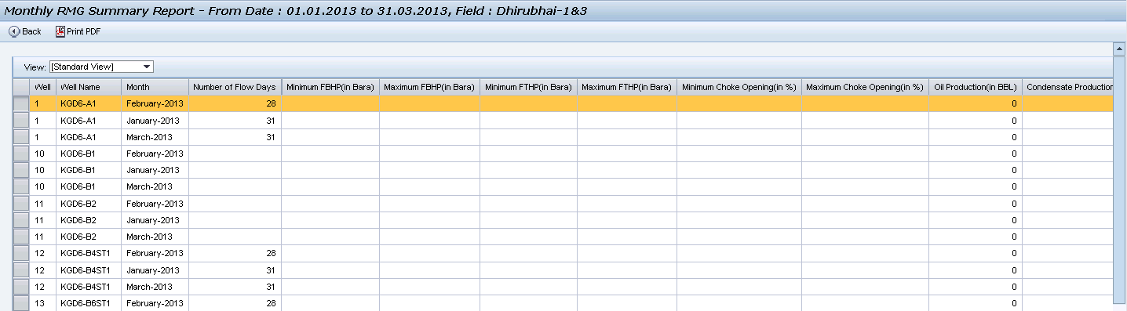

**Print PDF button**

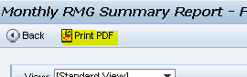

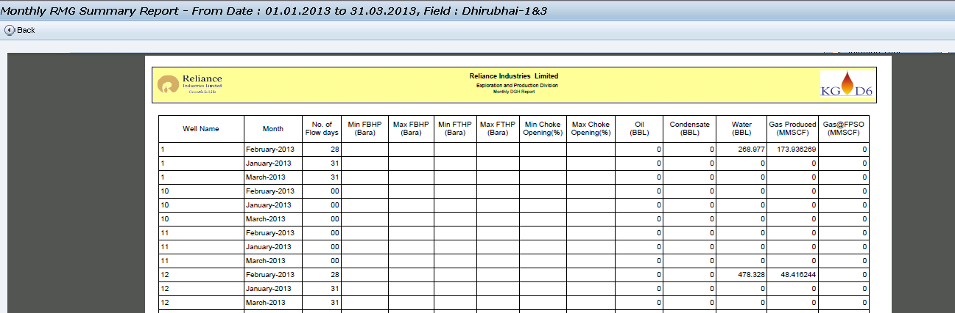

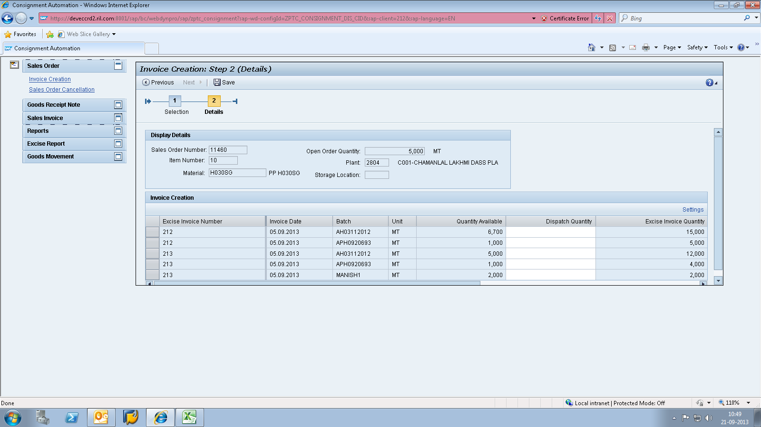

**Description: Invoice Creation**

|  |  |  |  |  |  |  |  |  |  |  |  |  |  |  |  |  |  |  |  |
| --- | --- | --- | --- | --- | --- | --- | --- | --- | --- | --- | --- | --- | --- | --- | --- | --- | --- | --- | --- |
| |  | | --- | |  | |  |  |  |  |  |  |  |  |  |  |  |  |  |  |  |  |  |  |
|  |  |  |  |  |  |  |  |  |  |  |  |  |  |  |  |  |  |  |
|  |  |  |  |  |  |  |  |  |  |  |  |  |  |  |  |  |  |  |
|  |  |  |  |  |  |  |  |  |  |  |  |  |  |  |  |  |  |  |
|  |  |  |  |  |  |  |  |  |  |  |  |  |  |  |  |  |  |  |
|  |  |  |  |  |  |  |  |  |  |  |  |  |  |  |  |  |  |  |
|  |  |  |  |  |  |  |  |  |  |  |  |  |  |  |  |  |  |  |
|  |  |  |  |  |  |  |  |  |  |  |  |  |  |  |  |  |  |  |
|  |  |  |  |  |  |  |  |  |  |  |  |  |  |  |  |  |  |  |
|  |  |  |  |  |  |  |  |  |  |  |  |  |  |  |  |  |  |  |
|  |  |  |  |  |  |  |  |  |  |  |  |  |  |  |  |  |  |  |
|  |  |  |  |  |  |  |  |  |  |  |  |  |  |  |  |  |  |  |
|  |  |  |  |  |  |  |  |  |  |  |  |  |  |  |  |  |  |  |
|  |  |  |  |  |  |  |  |  |  |  |  |  |  |  |  |  |  |  |
|  |  |  |  |  |  |  |  |  |  |  |  |  |  |  |  |  |  |  |
|  |  |  |  |  |  |  |  |  |  |  |  |  |  |  |  |  |  |  |
|  |  |  |  |  |  |  |  |  |  |  |  |  |  |  |  |  |  |  |
|  |  |  |  |  |  |  |  |  |  |  |  |  |  |  |  |  |  |  |
|  |  |  |  |  |  |  |  |  |  |  |  |  |  |  |  |  |  |  |
|  |  |  |  |  |  |  |  |  |  |  |  |  |  |  |  |  |  |  |
|  |  |  |  |  |  |  |  |  |  |  |  |  |  |  |  |  |  |  |
|  |  |  |  |  |  |  |  |  |  |  |  |  |  |  |  |  |  |  |
|  |  |  |  |  |  |  |  |  |  |  |  |  |  |  |  |  |  |  |
| **Description : Sales Order Cancellation** |  |  |  |  |  |  |  |  |  |  |  |  |  |  |  |  |  |  |
|  |  |  |  |  |  |  |  |  |  |  |  |  |  |  |  |  |  |  |
| **Description :Create Stock Transfer Requisition** |  |  |  |  |  |  |  |  |  |  |  |  |  |  |  |  |  |  |
|  |  |  |  |  |  |  |  |  |  |  |  |  |  |  |  |  |  |  |
|  |  |  |  |  |  |  |  |  |  |  |  |  |  |  |  |  |  |  |
| **Description : Creation for Stock Transfer Order** |  |  |  |  |  |  |  |  |  |  |  |  |  |  |  |  |  |  |
| **Description : Goods Receipt** |  |  |  |  |  |  |  |  |  |  |  |  |  |  |  |  |  |  |
|  |  |  |  |  |  |  |  |  |  |  |  |  |  |  |  |  |  |  |
|  |  |  |  |  |  |  |  |  |  |  |  |  |  |  |  |  |  |  |
|  |  |  |  |  |  |  |  |  |  |  |  |  |  |  |  |  |  |  |
|  |  |  |  |  |  |  |  |  |  |  |  |  |  |  |  |  |  |  |
|  |  |  |  |  |  |  |  |  |  |  |  |  |  |  |  |  |  |  |
|  |  |  |  |  |  |  |  |  |  |  |  |  |  |  |  |  |  |  |
|  |  |  |  |  |  |  |  |  |  |  |  |  |  |  |  |  |  |  |
|  |  |  |  |  |  |  |  |  |  |  |  |  |  |  |  |  |  |  |
|  |  |  |  |  |  |  |  |  |  |  |  |  |  |  |  |  |  |  |
|  |  |  |  |  |  |  |  |  |  |  |  |  |  |  |  |  |  |  |
|  |  |  |  |  |  |  |  |  |  |  |  |  |  |  |  |  |  |  |
|  |  |  |  |  |  |  |  |  |  |  |  |  |  |  |  |  |  |  |
|  |  |  |  |  |  |  |  |  |  |  |  |  |  |  |  |  |  |  |
|  |  |  |  |  |  |  |  |  |  |  |  |  |  |  |  |  |  |  |
|  |  |  |  |  |  |  |  |  |  |  |  |  |  |  |  |  |  |  |
|  |  |  |  |  |  |  |  |  |  |  |  |  |  |  |  |  |  |  |
| |  | | --- | |  | |  |  |  |  |  |  |  |  |  |  |  |  |  |  |  |  |  |  |
|  |  |  |  |  |  |  |  |  |  |  |  |  |  |  |  |  |  |  |
|  |  |  |  |  |  |  |  |  |  |  |  |  |  |  |  |  |  |  |
|  |  |  |  |  |  |  |  |  |  |  |  |  |  |  |  |  |  |  |
|  |  |  |  |  |  |  |  |  |  |  |  |  |  |  |  |  |  |  |
| **Description : Provisional Goods Receipt** |  |  |  |  |  |  |  |  |  |  |  |  |  |  |  |  |  |  |
|  |  |  |  |  |  |  |  |  |  |  |  |  |  |  |  |  |  |  |
|  |  |  |  |  |  |  |  |  |  |  |  |  |  |  |  |  |  |  |
|  |  |  |  |  |  |  |  |  |  |  |  |  |  |  |  |  |  |  |
|  |  |  |  |  |  |  |  |  |  |  |  |  |  |  |  |  |  |  |
|  |  |  |  |  |  |  |  |  |  |  |  |  |  |  |  |  |  |  |
|  |  |  |  |  |  |  |  |  |  |  |  |  |  |  |  |  |  |  |
|  |  |  |  |  |  |  |  |  |  |  |  |  |  |  |  |  |  |  |
|  |  |  |  |  |  |  |  |  |  |  |  |  |  |  |  |  |  |  |
|  |  |  |  |  |  |  |  |  |  |  |  |  |  |  |  |  |  |  |
|  |  |  |  |  |  |  |  |  |  |  |  |  |  |  |  |  |  |  |
|  |  |  |  |  |  |  |  |  |  |  |  |  |  |  |  |  |  |  |
|  |  |  |  |  |  |  |  |  |  |  |  |  |  |  |  |  |  |  |
|  |  |  |  |  |  |  |  |  |  |  |  |  |  |  |  |  |  |  |
|  |  |  |  |  |  |  |  |  |  |  |  |  |  |  |  |  |  |  |
|  |  |  |  |  |  |  |  |  |  |  |  |  |  |  |  |  |  |  |
|  |  |  |  |  |  |  |  |  |  |  |  |  |  |  |  |  |  |  |
| **Description : Pending Provisional Goods Receipt Listing** |  |  |  |  |  |  |  |  |  |  |  |  |  |  |  |  |  |  |
|  |  |  |  |  |  |  |  |  |  |  |  |  |  |  |  |  |  |  |
|  |  |  |  |  |  |  |  |  |  |  |  |  |  |  |  |  |  |  |
|  |  |  |  |  |  |  |  |  |  |  |  |  |  |  |  |  |  |  |
|  |  |  |  |  |  |  |  |  |  |  |  |  |  |  |  |  |  |  |
|  |  |  |  |  |  |  |  |  |  |  |  |  |  |  |  |  |  |  |
|  |  |  |  |  |  |  |  |  |  |  |  |  |  |  |  |  |  |  |
|  |  |  |  |  |  |  |  |  |  |  |  |  |  |  |  |  |  |  |
|  |  |  |  |  |  |  |  |  |  |  |  |  |  |  |  |  |  |  |
|  |  |  |  |  |  |  |  |  |  |  |  |  |  |  |  |  |  |  |
| **Description : Invoice Cancellation** |  |  |  |  |  |  |  |  |  |  |  |  |  |  |  |  |  |  |
|  |  |  |  |  |  |  |  |  |  |  |  |  |  |  |  |  |  |  |
|  |  |  |  |  |  |  |  |  |  |  |  |  |  |  |  |  |  |  |
|  |  |  |  |  |  |  |  |  |  |  |  |  |  |  |  |  |  |  |
|  |  |  |  |  |  |  |  |  |  |  |  |  |  |  |  |  |  |  |
|  |  |  |  |  |  |  |  |  |  |  |  |  |  |  |  |  |  |  |
|  |  |  |  |  |  |  |  |  |  |  |  |  |  |  |  |  |  |  |
|  |  |  |  |  |  |  |  |  |  |  |  |  |  |  |  |  |  |  |
|  |  |  |  |  |  |  |  |  |  |  |  |  |  |  |  |  |  |  |
| **Description : Print Excise Invoice** |  |  |  |  |  |  |  |  |  |  |  |  |  |  |  |  |  |  |
|  |  |  |  |  |  |  |  |  |  |  |  |  |  |  |  |  |  |  |
|  |  |  |  |  |  |  |  |  |  |  |  |  |  |  |  |  |  |  |
|  |  |  |  |  |  |  |  |  |  |  |  |  |  |  |  |  |  |  |

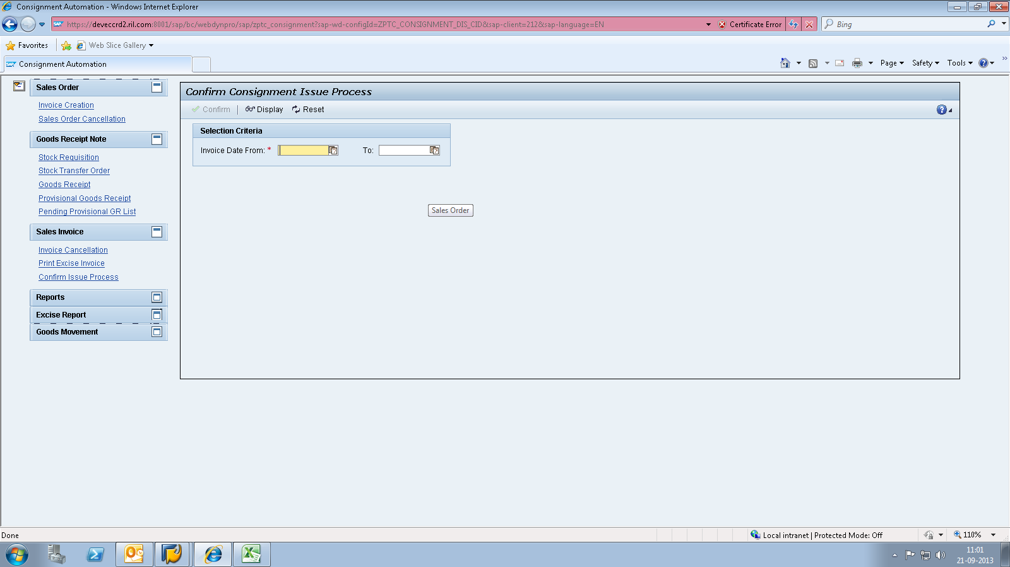 **Description : Confirm Consignment Issue Process**

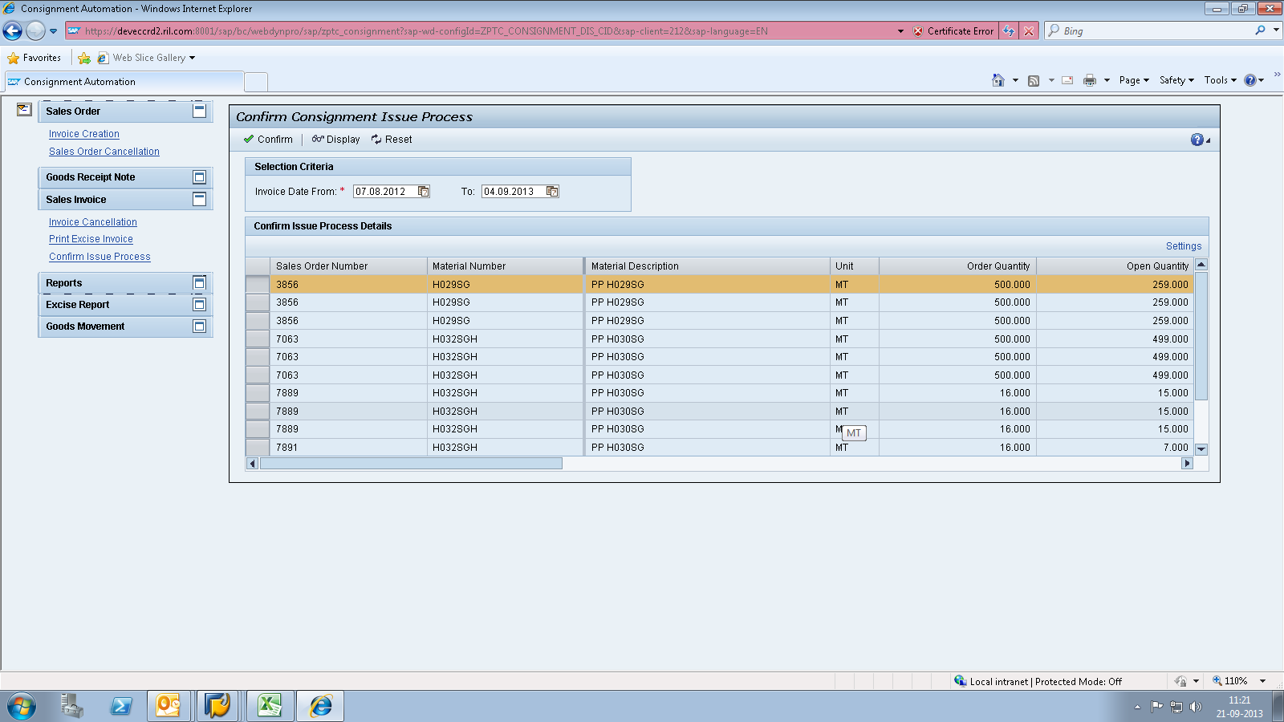

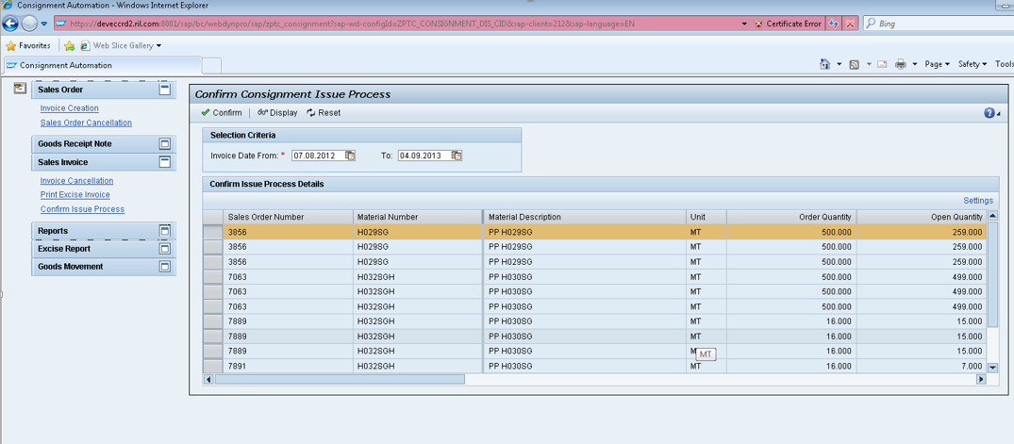

**Description: List of Stock Requisitions**

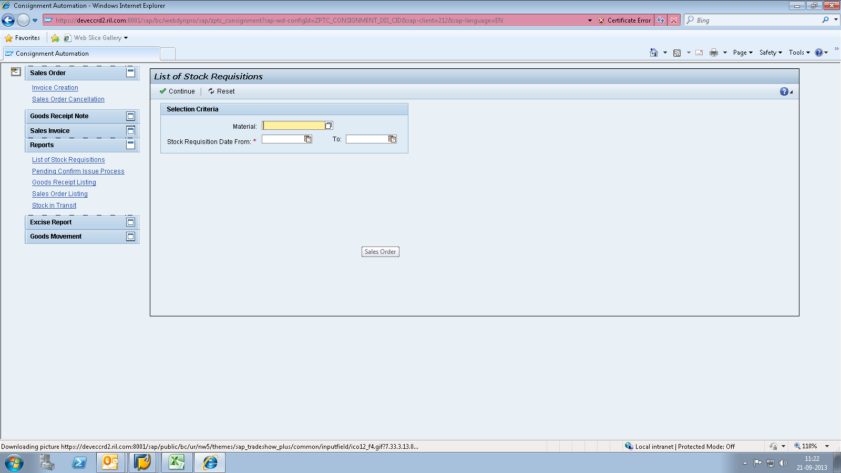

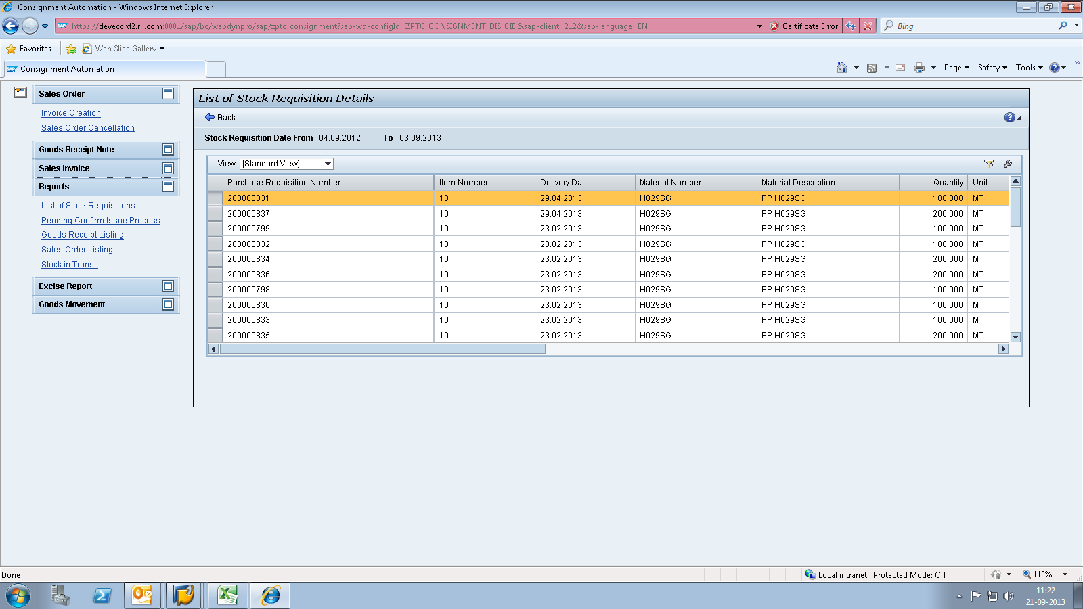

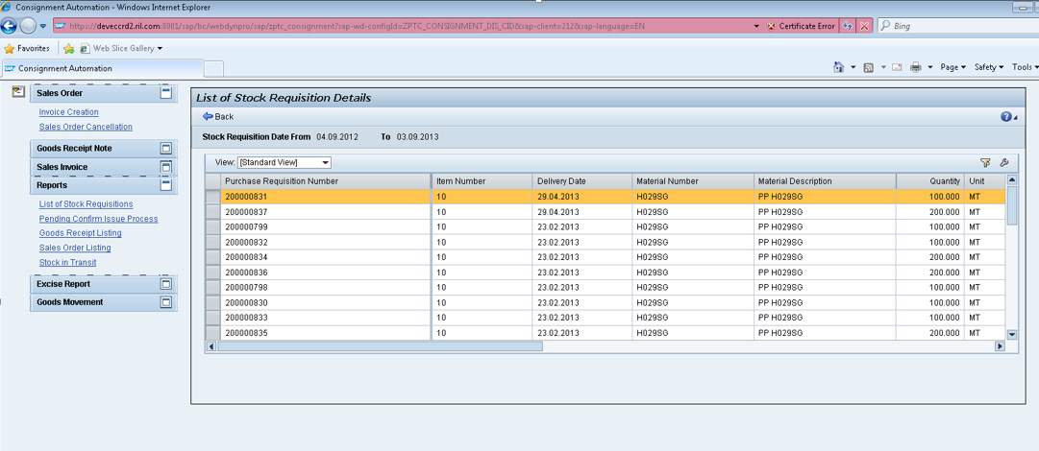

**Description : Pending Confirm Issue Processing Listing**

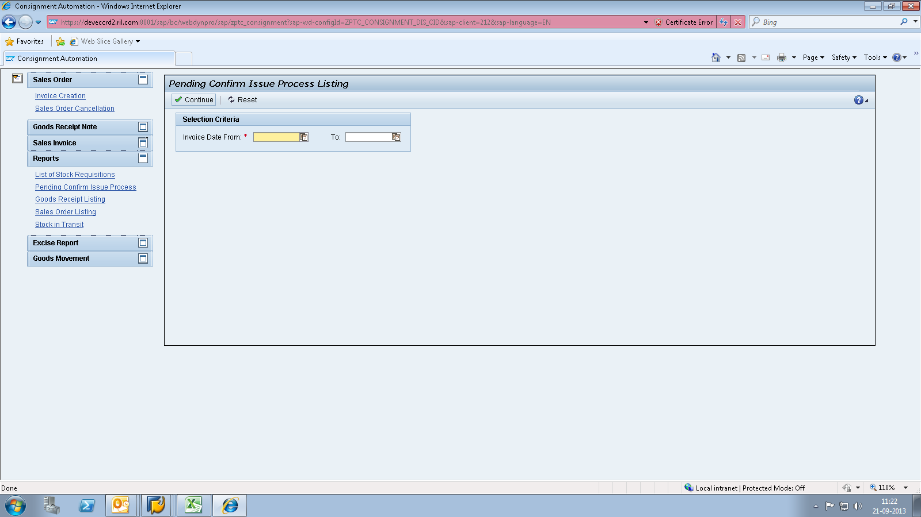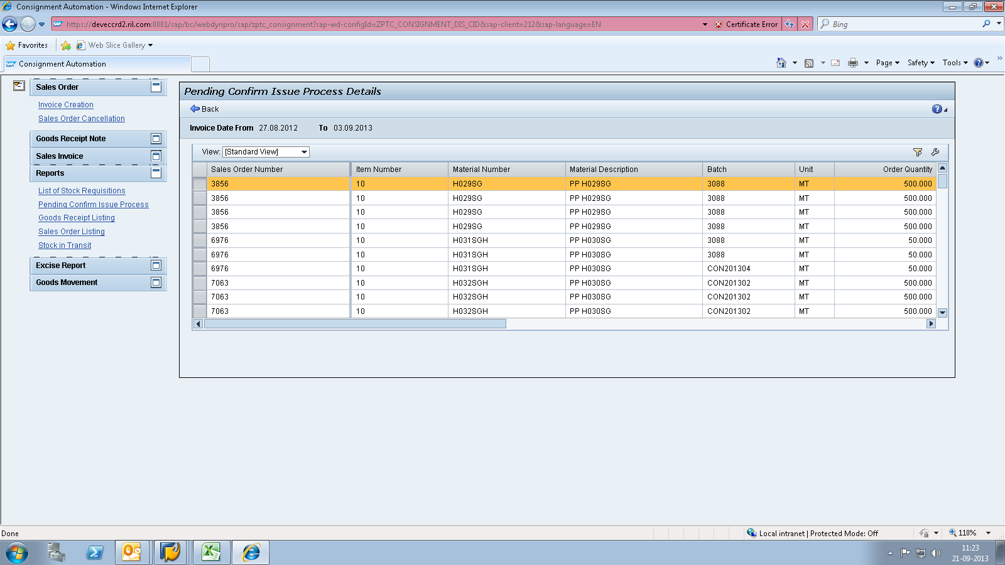

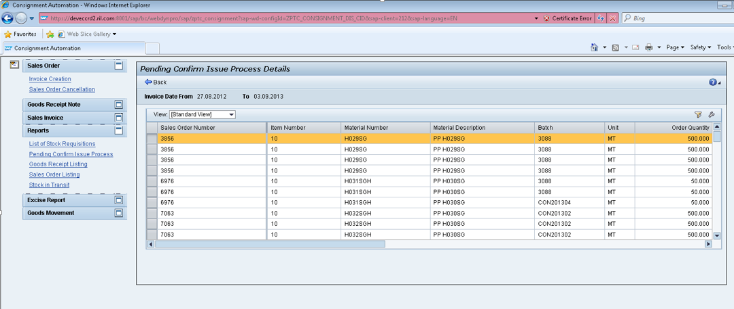

**Description: Goods Receipt Listing**

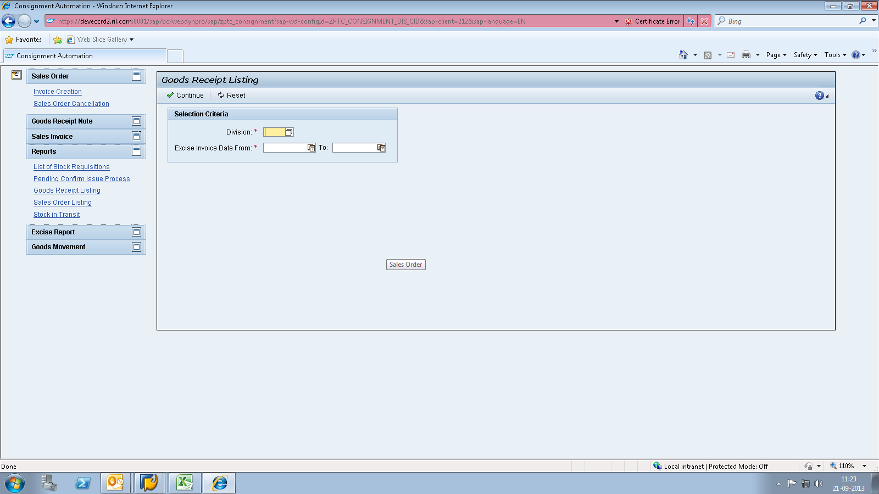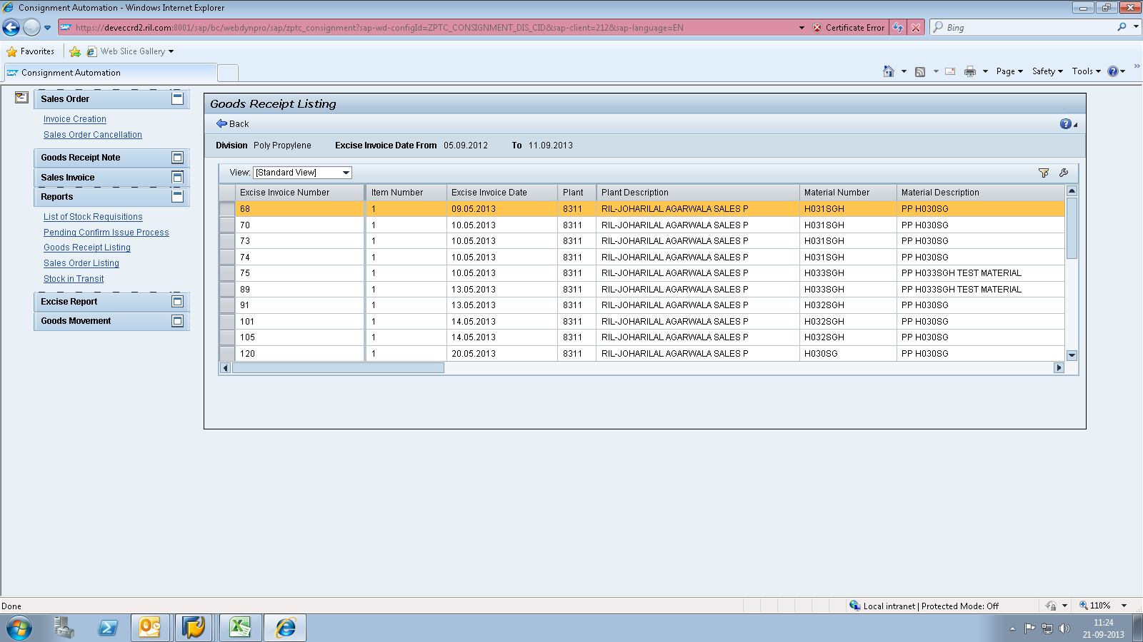

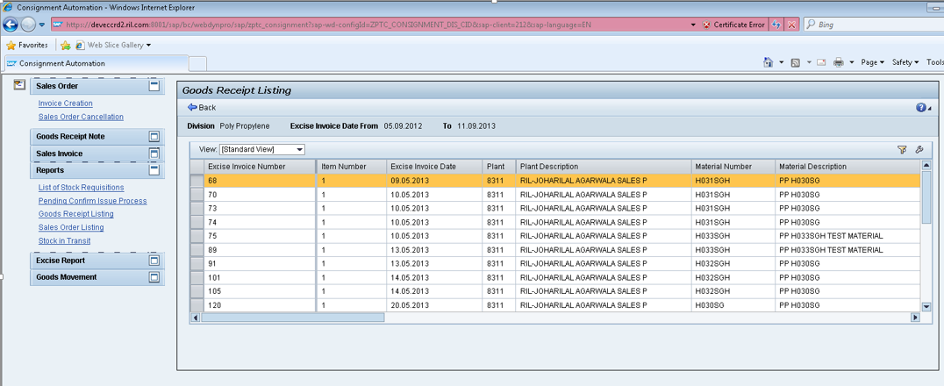

**Description: Sales Order Listing**

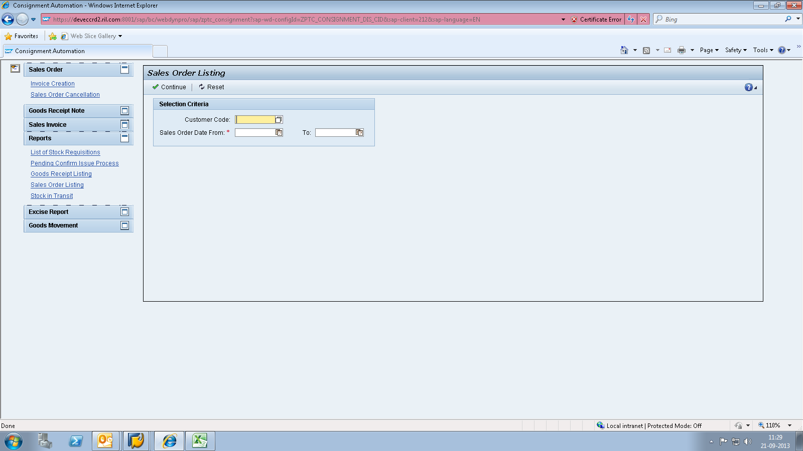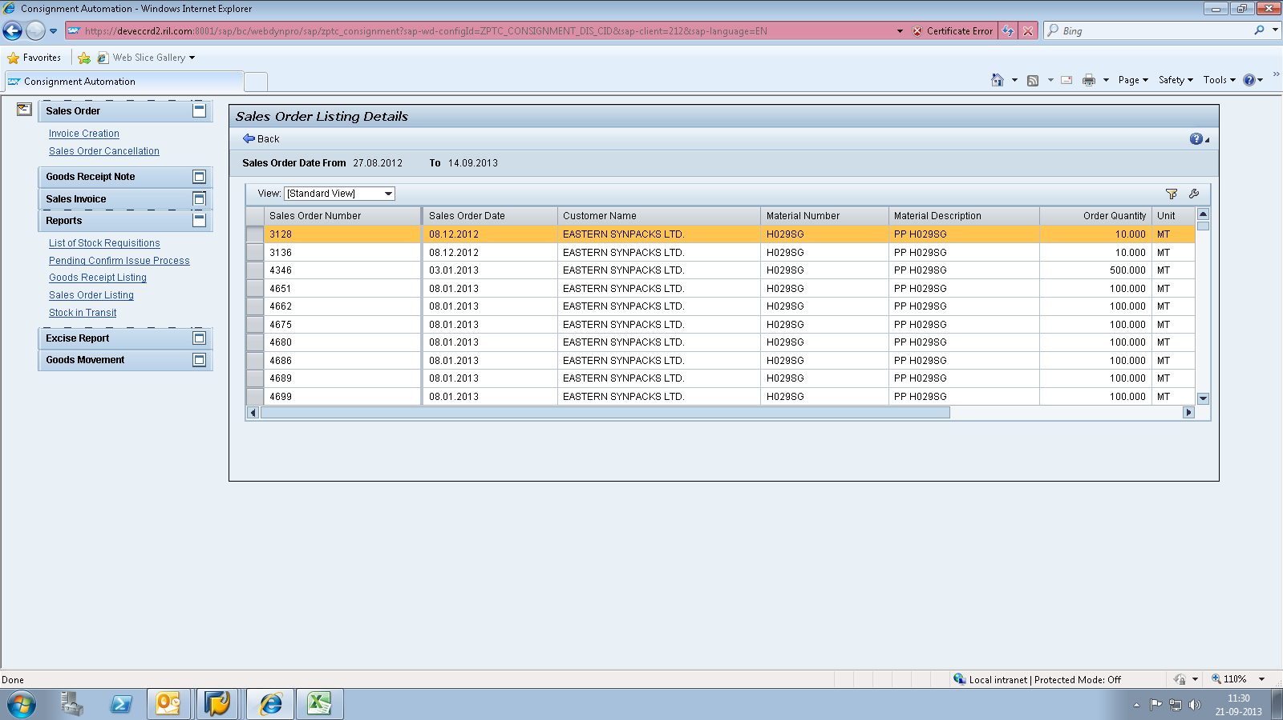

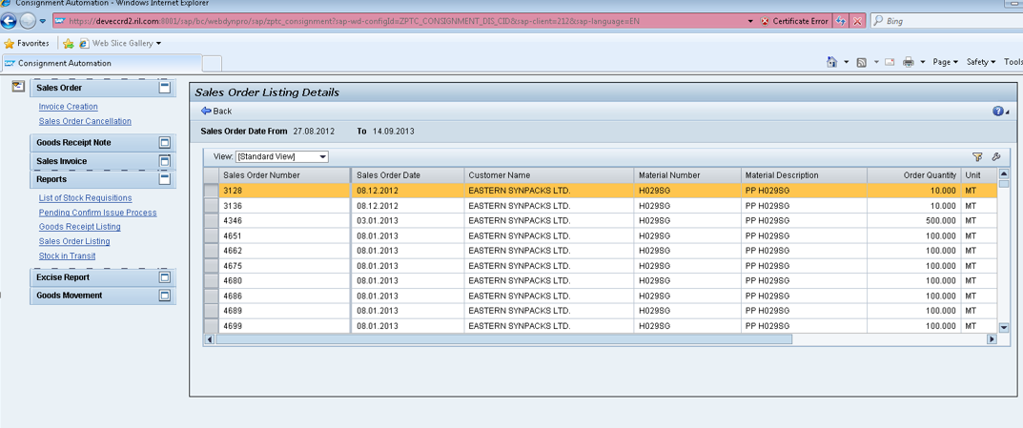

**Description: Stock in Transit**

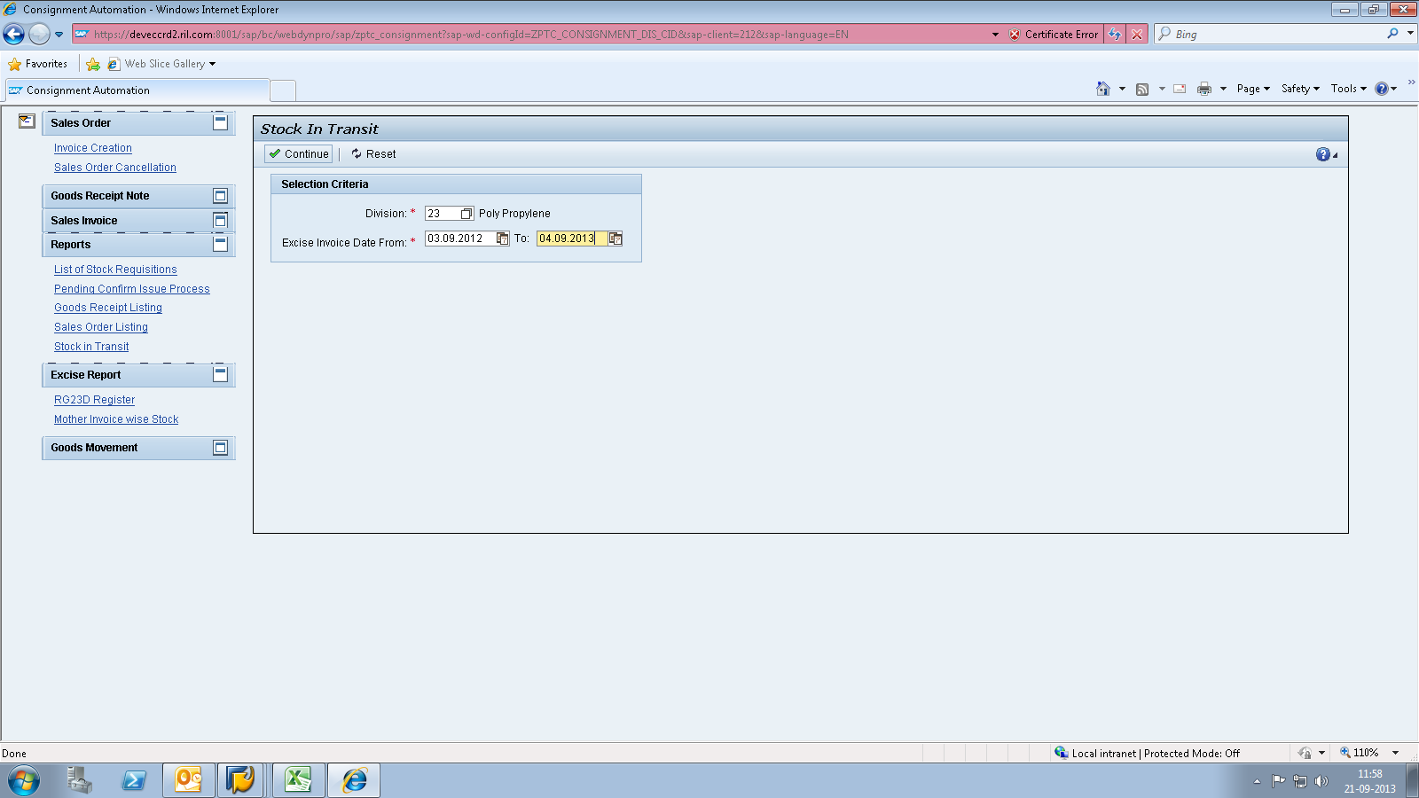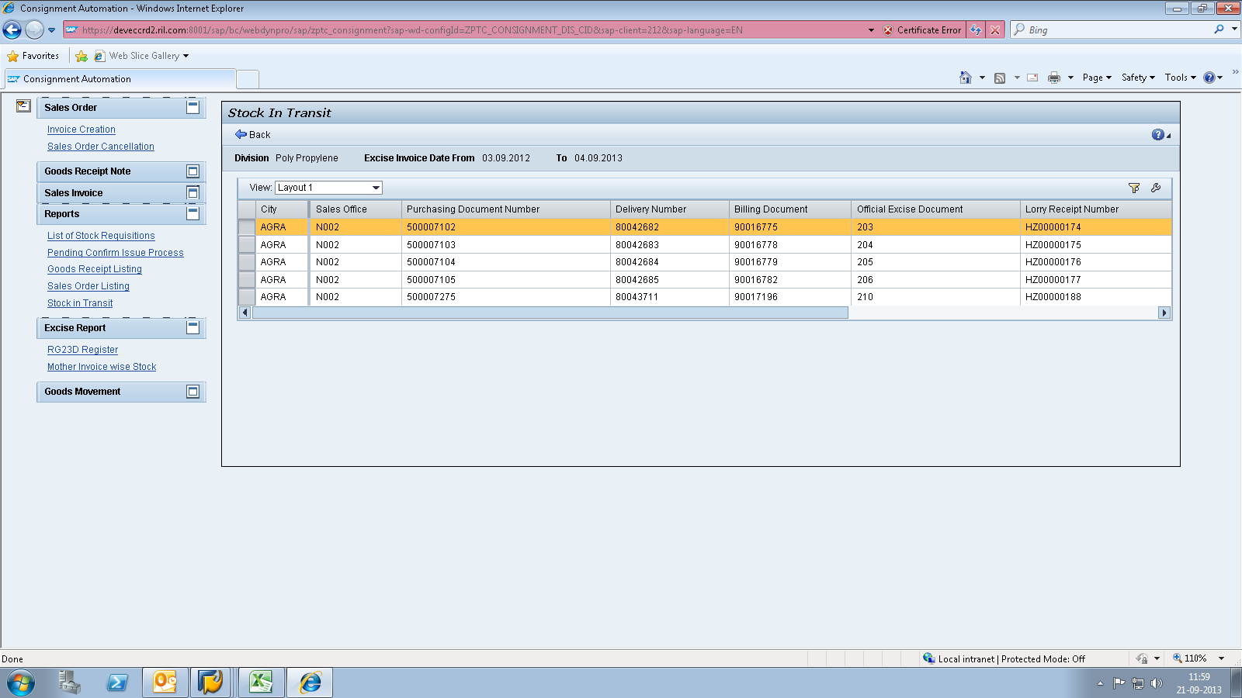

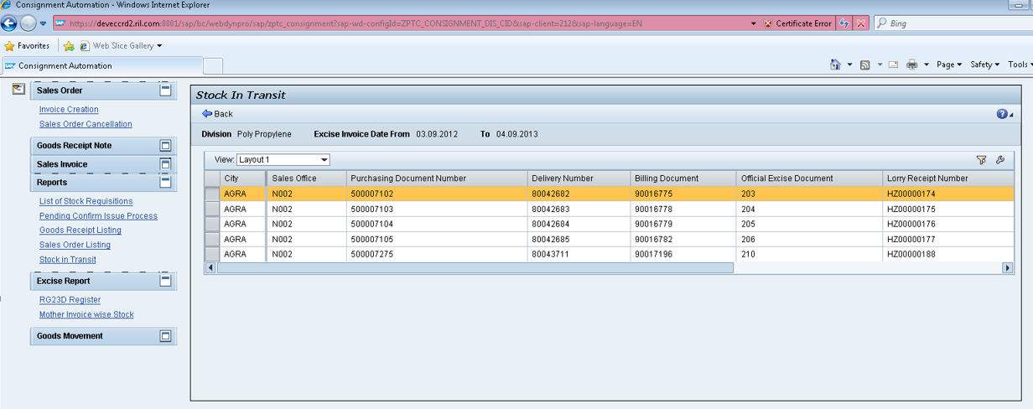

**Description: RG23D Register**

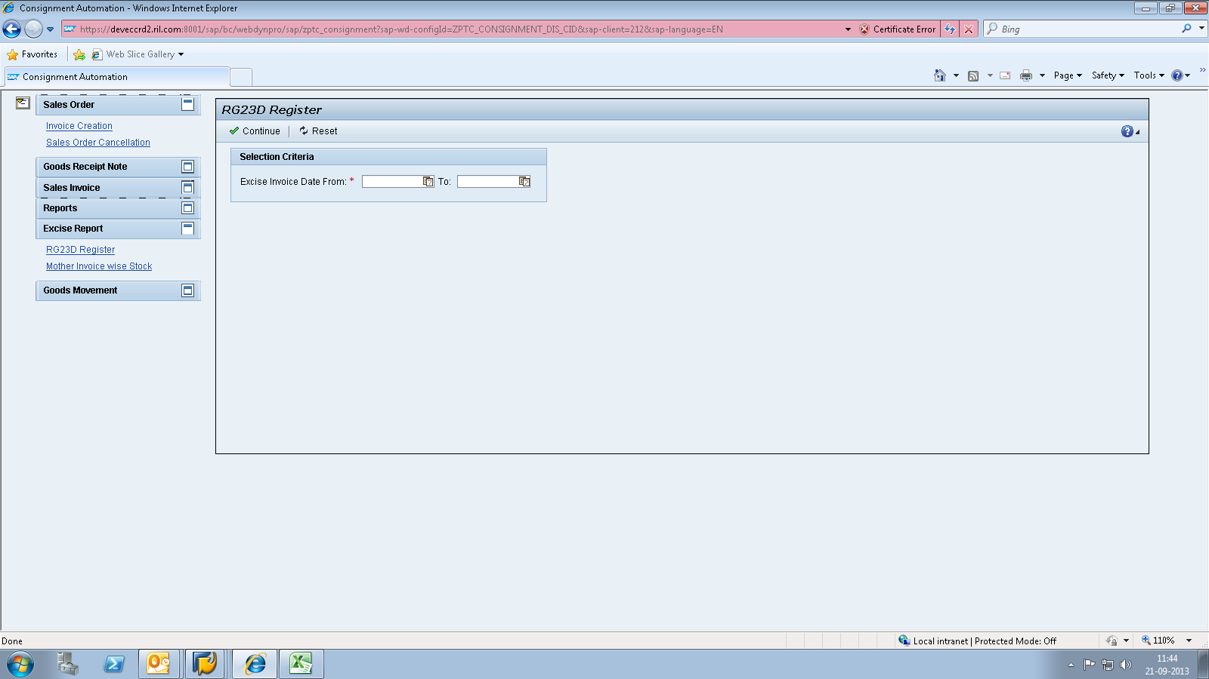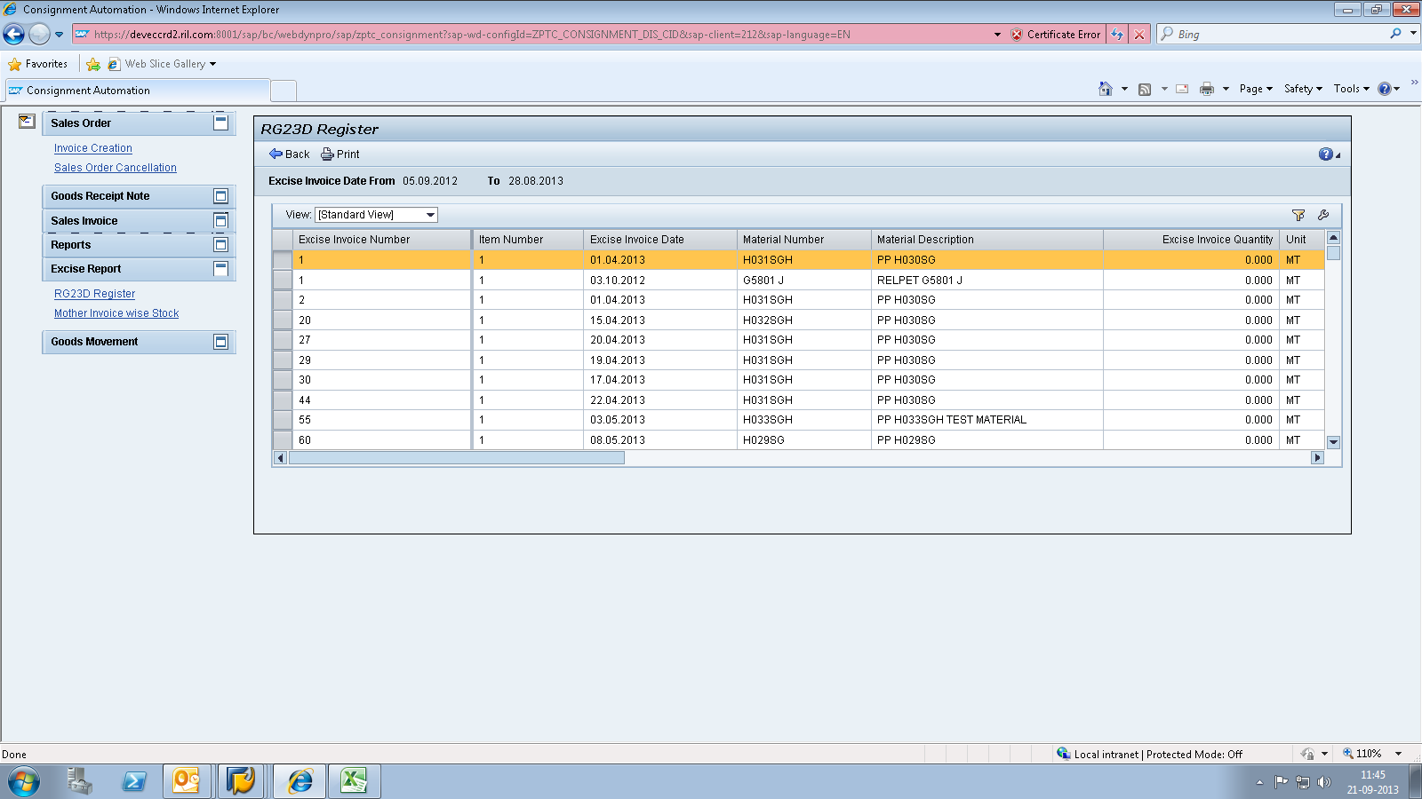

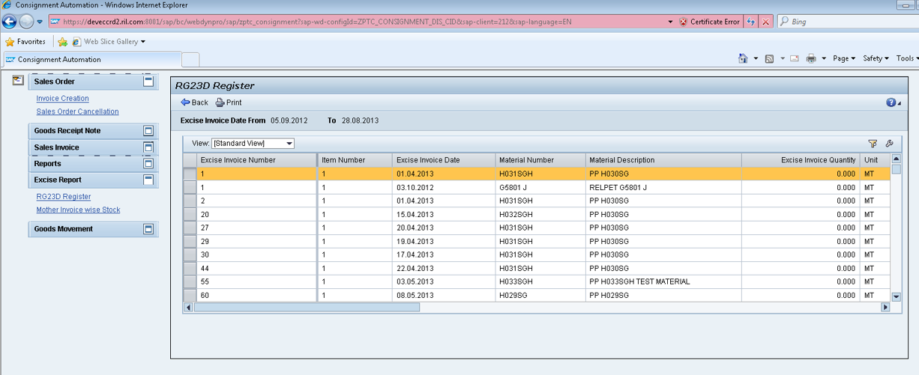

**Description: Invoice wise Stock Details**

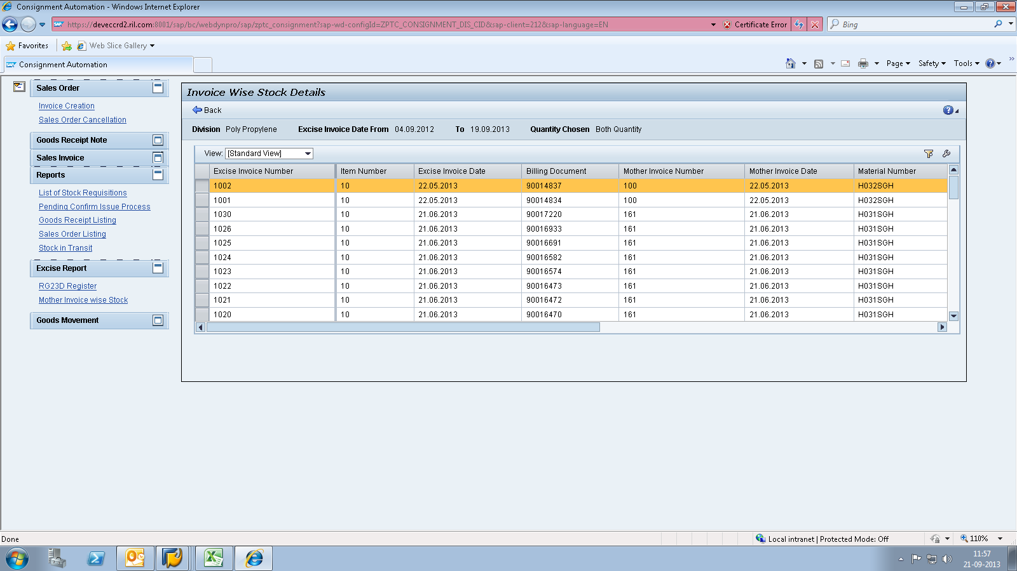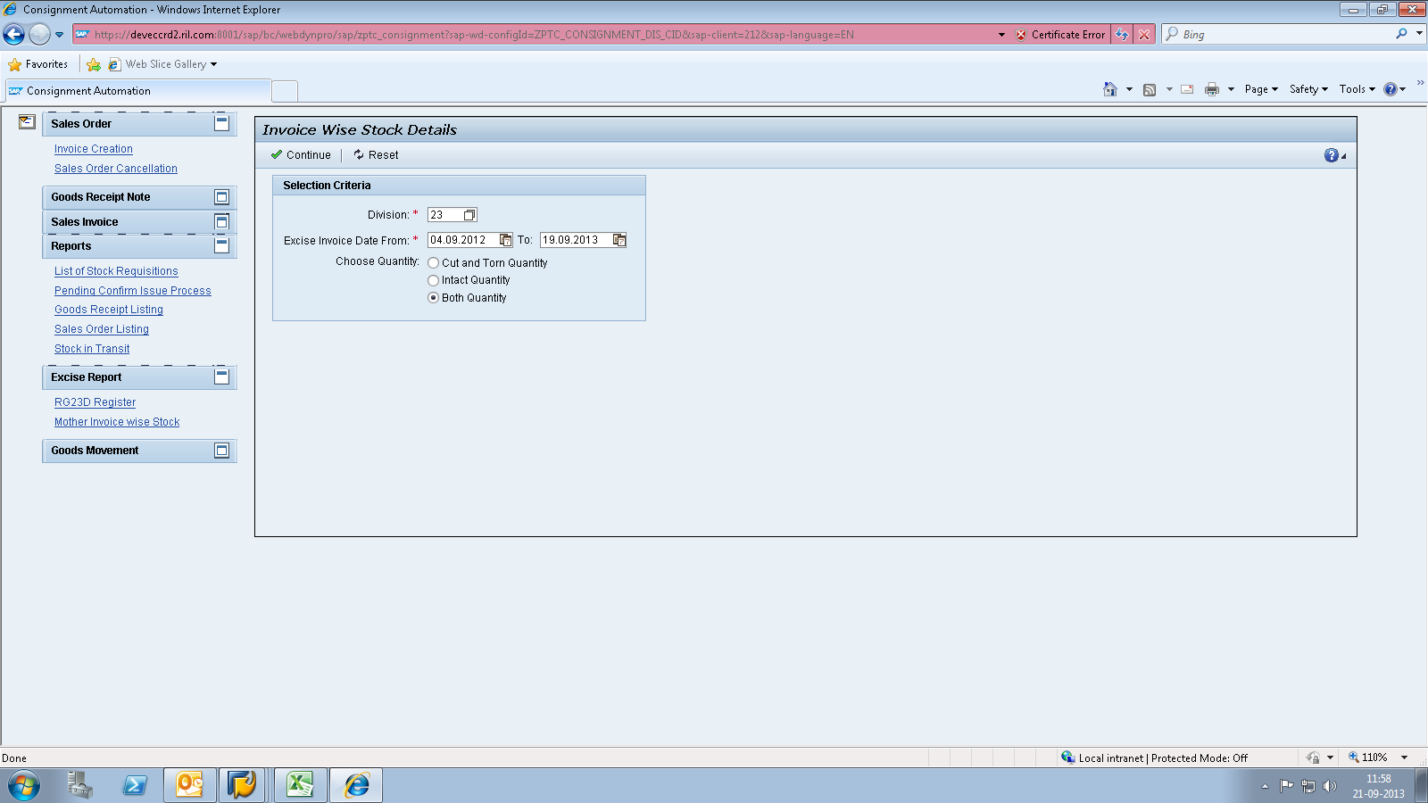

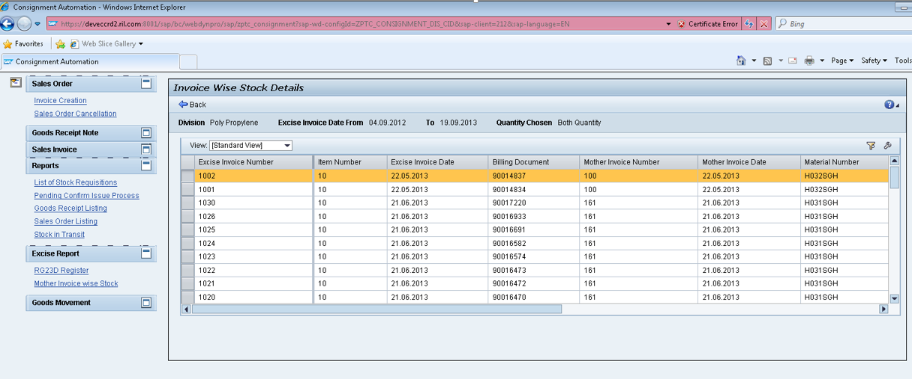

**Description: Location Transfer**

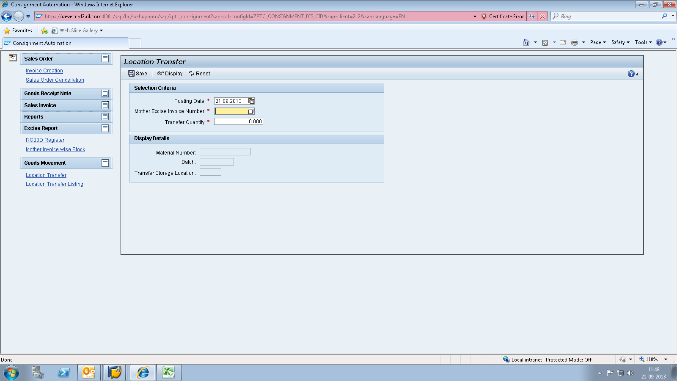

**Description: Location Transfer Listing Details**

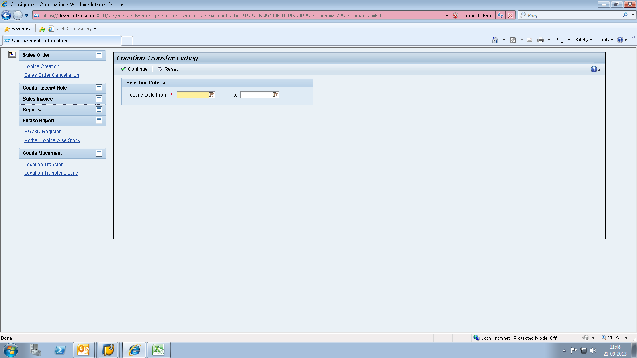

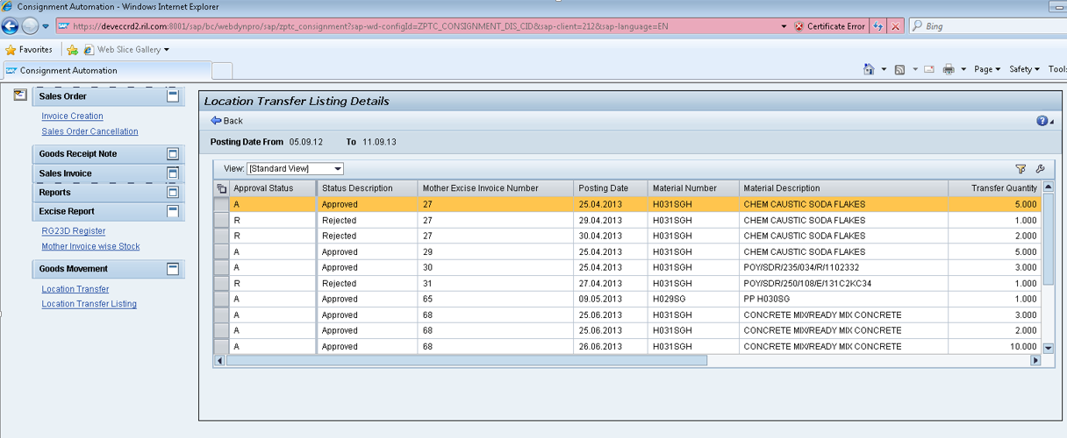



**Description : GTA Invoice.**

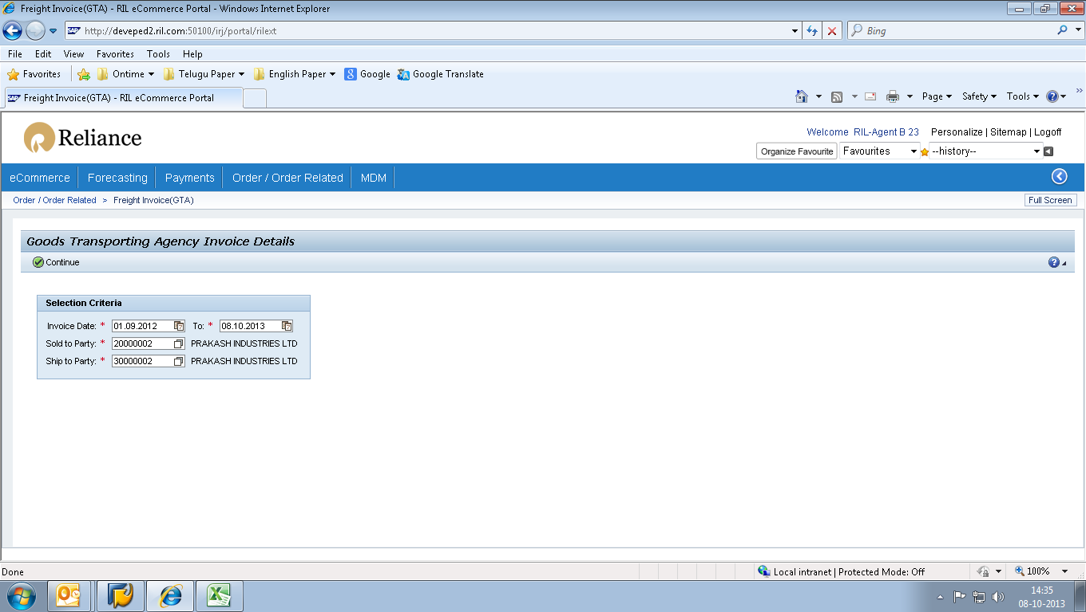

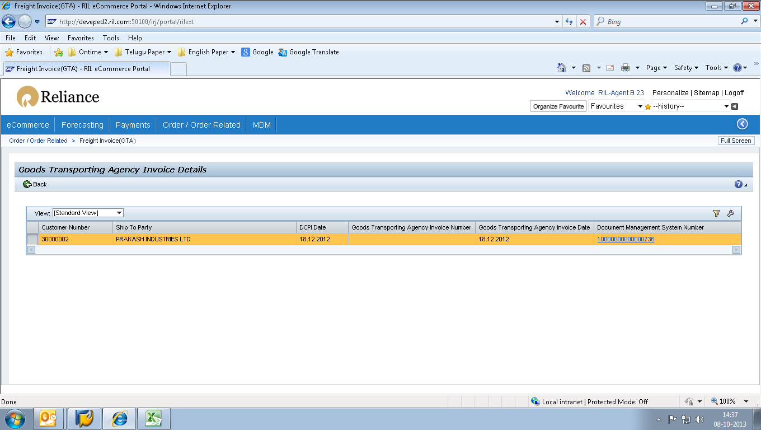

**Description: Order Status**

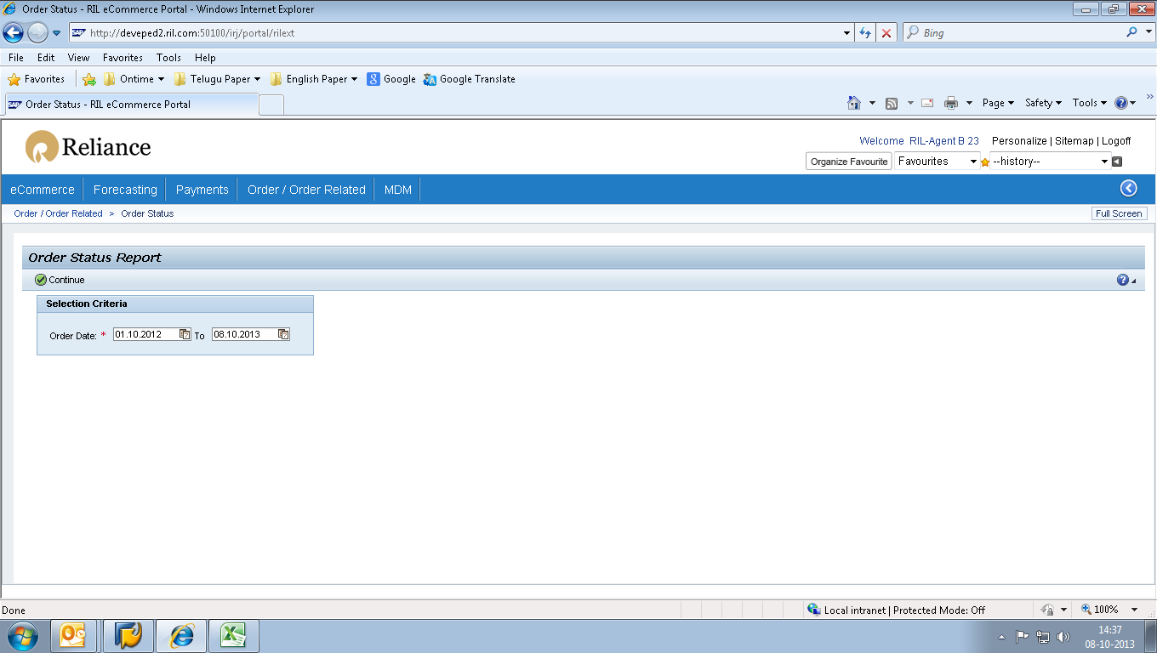

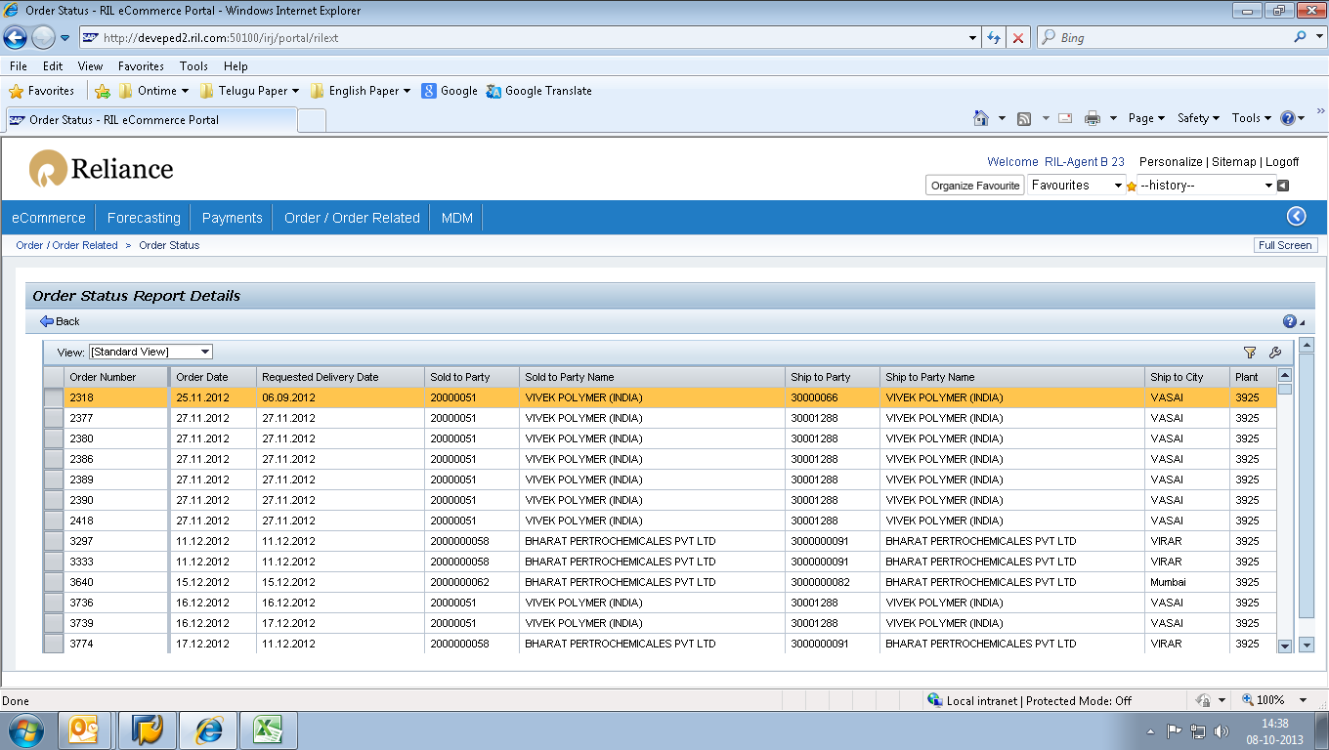

**Description: Dispatch Report**

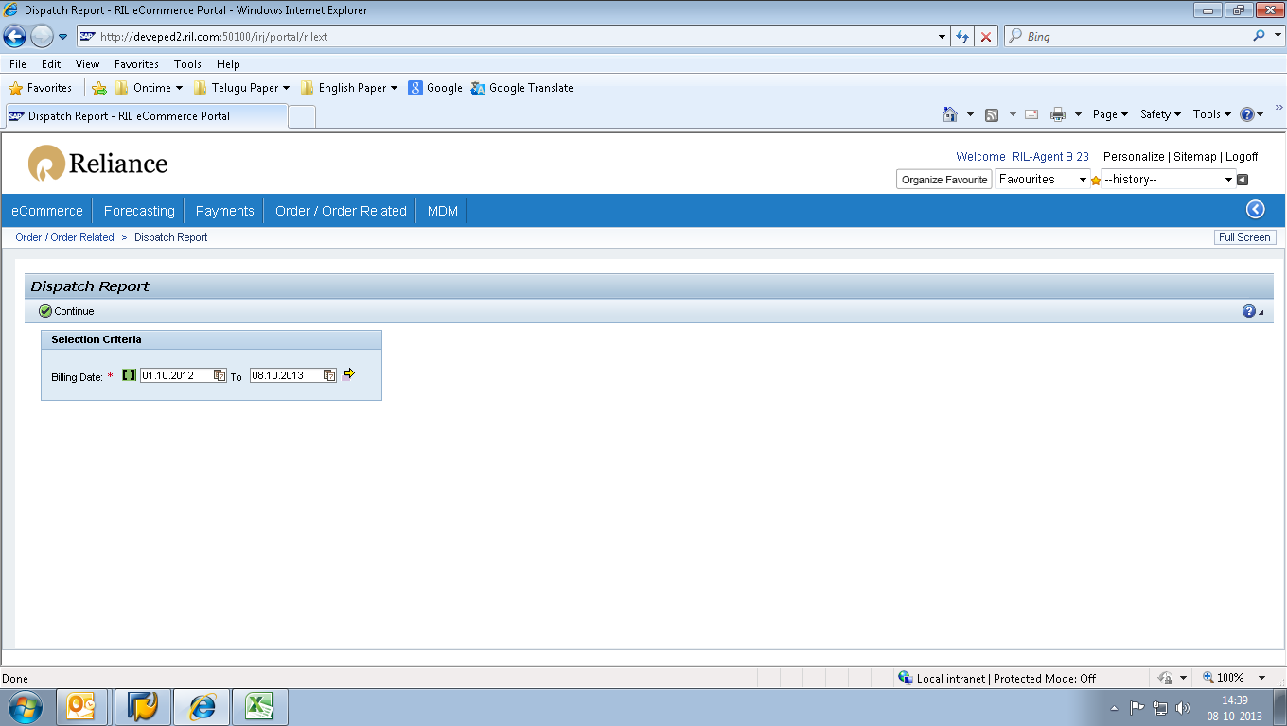

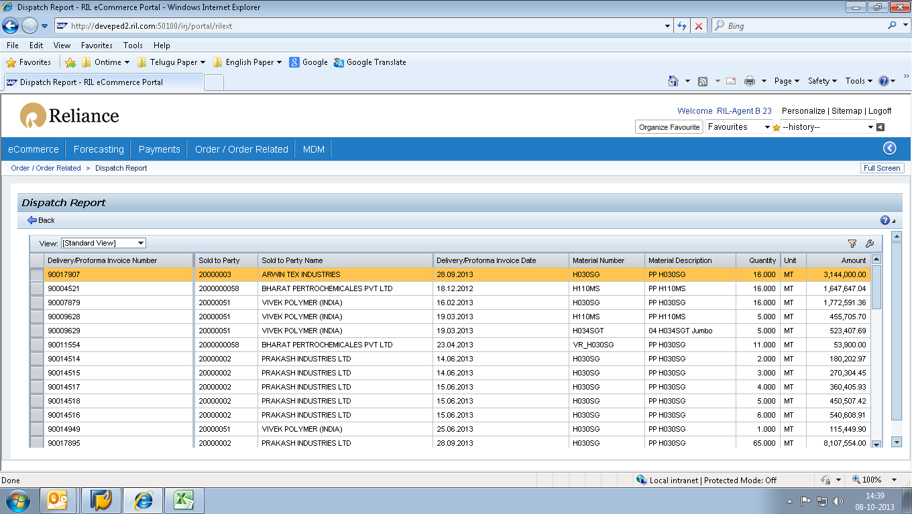

**Some Common Points:**

* Custom buttons should have proper icons cross verified from UI guidelines document.
* Radio buttons and checkboxes should be on left and its label should be right on selection screen.
* If more than 5 radio buttons are there on selection screen, dropdown for choice selection should be given.
* Blank layout, blank ALV should not be displayed. IF data doesn't exist for particular data, message should be displayed as 'No data to display'.
* On screens, frame inside frame should not be there.
* Explicit Download functionality as well as button for the same should not visible on screen.
* Field output in ALV or table control should not have leading zeros.
* Avoid spelling mistakes.
* Proper test data needed for UI Check.

**UI Guidelines Checklist:**

